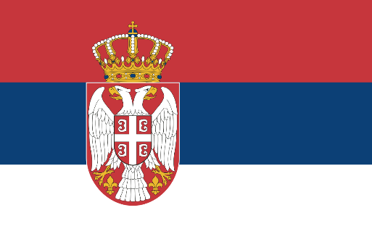Country: The Republic of Serbia

Committee: Social, Humanitarian & Cultural Committee (GA3: SOCHUM)

Agenda Item: Seeking Solutions for Human Rights Violations Derived from Ethnic Divides

The Balkan region is widely known as the ‘powder keg of Europe’ due to constant ethnic tensions throughout the history of the region. The breakup of Yugoslavia in 1990s is a perfect case in this category. The three Ethnic wars began after the death of Josip Broz Tito in 1980 and evidenced severe violence. In June 1991, Slovenia and Croatia demanded secession from the common state, and it was followed by military actions as JNA, which was filled with Serbs for the most part, intervened. The war of independence in Croatia was one of the most deadly wars in Europe in the 1990s and it was characterized by high casualties and massive displacement of people. The next conflict was the Bosnian War which lasted from 1992 to 1995 and saw horrendous acts such as genocide with the Srebrenica massacre of July 1995 in which more than 8000 Bosniak male civilian were killed. Moreover, the Kosovo issue emerged as early as in January 1998-1999, on the background of which ethnic Albanians demanded independence from Serbia. The NATO actions in March 1999 resulted in the bombings of Serbia & Montenegro to out come of Kumanovo Agreement in June 1999 with the formation of UNMIK.

The ethnic conflict in Serbia has been a major issue in the post-Yugoslav period but efforts have been made to bring this into an end and pave way for regional stability. Our government understands the need of reconciliation, cooperation at regional level as well as compliance with the rule of international law in the context of sustainable peace in the world. Serbia is a member of United Nations, OSCE councils and council of Europe and committed on international diplomacy resolutions of the ethnic problems. Serbia has complied with the ICTY in identifying and punishing people guilty of war crimes showing commitment in the quest for accountability than retribution. Serbia has also engaged in reconciliation and economic integration processes in the western Balkan region. The Berlin Process was launched in 2014 to foster connectivity, economic cooperation, and integration as well as reconciliation. Serbia and Kosovo normalized relations in 2013 when they signed the Brussels Agreement which was facilitated by the EU. Serbia is committed to the defense of ethnic minorities living within the territory of Serbia. Serbian Constitution and legal systems protect the rights of the national minorities and their cultural, educational and language rights. The National Councils of National Minorities Act that was passed in the year 2009 allows minority groups to govern their own culture and education. Ethnic conflicts cannot be described as simple and easily solvable, which is why international cooperation is needed. Serbia’s approach is an integrated one that entails preventive diplomacy, conflict management and post conflict reconstruction. Preventive diplomacy therefore plays a crucial role in dealing with ethnic conflicts before they lead to physical conflict. They should support early warning mechanisms, mediation, and fully representative political processes. The grievances that foster ethnic tensions can be tackled through enhancing local governance and the advancement of the economic welfare. Conflict management requires quick intervention and decision making to avoid further deterioration of the conflict. The United Nations and other regional organizations, such as the OSCE, need to improve their ability to quickly respond and mediate in conflicts. It should be noted that Serbia is in favour of the application of peacekeeping operations where necessary for ensuring order and safeguarding the civilian population. Reconstruction is therefore important after any conflict so as to support sustainable peace. This includes reconstruction and restoration, contributing to economic revival, and concern for post-war and post-evacuation populations. Truth commissions and reparations are important in restoring societies and rebuilding trust after conflict.

To conclude, In organizational Membership the Republic of Serbia has pledged its commitment to address ethnic conflicts in the modern world. Many of the conflicts reveal a very gruesome end, but they have also helped us understand the importance of post-war reconstruction and compliance to the international law. Serbia is willing to challenge, contribute into, promote and cooperate with all the countries that are willing and seeking to create a world which would be cooperative, safe and tolerant.