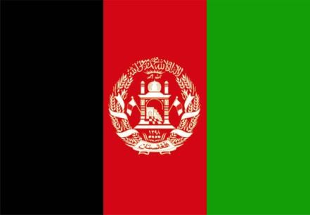Country: Afghanistan Commmittee:SOCHUM

Agenda Item: The Childen’s Access to Educational Opportunities and Strubble with Child Labor

Afghanistan,is a landlocked country located at the crossroads of Central Asia and South Asia.Its economy depends mostly on animal husbandry, agriculture and trade with other countries.The economy of Afghanistan is listed as the [124th](https://en.wikipedia.org/wiki/List_of_countries_by_GDP_(nominal))

[largest in the world](https://en.wikipedia.org/wiki/List_of_countries_by_GDP_(nominal)) in terms of nominal [gross domestic product](https://en.wikipedia.org/wiki/Gross_domestic_product).Its population is nearly 32 million people.Approximately forty-two percent of the population consists of children aged 0 – 14.There is a big problem that these children face.It is the problem named child labor.Child labor is an issue of growing concern in Afghanistan.

Every one in four Afghan children aged 7 to 14 is engaged in some form of work.These children are forced to work instead of receiving education. 2 million school dropout children in Afghanistan work under harsh conditions to help their families.Afghan children mainly work as vendors, blacksmiths, mechanics and painters.Making Afghan children work prevents them from going to school.25 percent of Afghan children, are forced to work.60 percent of the girls are deprived of education.There are 4,2 million children aren’t going to school in total and 2,2 million of these children are girls.

We suggest that measures should be taken to prevent children from working and families should be made aware of this issue.Children should be supported in the field of education and children should not be forced to work under any circumstances.Their rights should be guaranteed.

The solution to all problems lies in education.