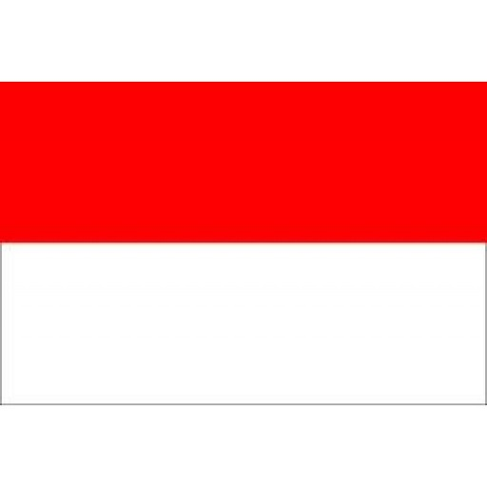Country:Indonesia

Community:WIPO

Agenda Item:Protecting Young Entrepreneurs and Their Inventions With Intellectual Property Rights

Delegate Name: Yiğitalp Kurbanoğlu

Intellectual Property Right is a law concept that ensures protection of peoples or companies intellectual productions,innovator works and creative creations.

## Indonesia is a country that 277,5 million people live in Indonesia which is the 4th most populated country in the world. Indonesia’s economy is the best economy in the Southheast Asia. In the world they have 16th best economy. Indonesia is the biggest island country in the world. With 1.904.569 km2 area, Indonesia is the 14th biggest country in the world.

Indonesia has ratified various international agreements on intellectual property rights. Indonesia is also a signatory to the ASEAN Patent Examination Cooperation which can allow applicants to obtain patents in and across other participating ASEAN countries, faster and more efficiently.

The following types of intellectual property are protected:

Trademarks

Patents

Copyrights

Indonesia might be the best country in the world for being fair about property rights. Also they have tough punishments. Violation of the property rights is one of the biggest crime in Indonesia.But Also most of the crimes happen in Indonesia. The government has to be more careful about this issue.