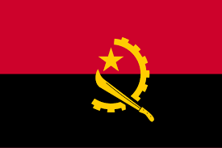Country: Angola

Agenda: Child Deaths and Health Solutions

Committee: UNFPA

Delegate: Demir Yiğit

Angola, located in southern Africa, borders Namibia, Zambia, the Democratic Republic of Congo, and the Atlantic Ocean. Despite being one of Africa’s largest oil producers, over 40% of its 35 million people live in poverty. Angola’s healthcare infrastructure is underdeveloped, with only 3.3% of GDP spent on health and limited access to medical care in rural areas.

Angola’s child mortality crisis stems from years of civil war (1975–2002), which destroyed infrastructure and displaced millions. Today, preventable diseases like malaria, diarrhea, and pneumonia, compounded by malnutrition, are the leading causes of death among children under five. Organizations such as UNICEF, WHO, USAID, and donor countries like China and the EU have supported efforts in immunization, nutrition, and sanitation, but challenges remain, particularly in rural areas.

To strength healthcare system we suggest to build rural clinics, train healthcare workers, and ensure the availability of medicines and vaccines. To struggle malnutrition, we should expand nutrition programs, distribute supplements, and promote breastfeeding. We should provide clean water systems and promote hygiene practices to improve sanitation. Prevent. To prevent diseases, we suggest to scale up immunizations, distribute mosquito nets, and provide affordable treatments for infections. We need to continue partnerships with global organizations and donors to finance healthcare reforms. We should train local health workers and educate families on healthy practices.