*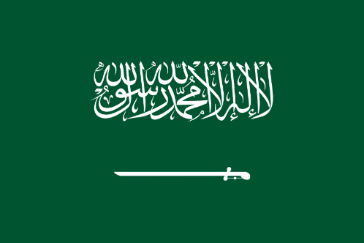*

Country: Saudi Arabia

Committee:SOCHUM

Agenda Item: Children's access to educational opportunities and the fight against child labor

Delegate:Yusuf USLU

Saudi Arabia is a Muslim country located on the Arabian Peninsula. Its total area is 2,149,690 square kilometers and its population is 36.95 million. The official language is Arabic and the currency of the country is the Arabian rial. Saudi Arabia is the second country with the most oil, with 267 billion barrels, and is also the country that exports the most oil in the world. But there is something that children in Saudi Arabia face, child labor.

Child labor is the employment of children in jobs that take away their childhood potential and harm the child's physical and mental development. Results of child labor include interfering with a child's education by depriving them of the ability to go to school as a result of their work. A child may have to drop out of school before completing it, or it may require the child to attend school along with long and difficult study. Working children are less likely to attend school, resulting in a less educated and less economically competitive population in the future. Fifteen percent of children and youth, who make up half of the population of Saudi Arabia, are child laborers. The majority of child labor in Saudi Arabia is concentrated in human trafficking, agriculture and family businesses

As a delegate of Saudi Arabia we suggest that families should be informed about the consequences of child labor and heavy penalties should be imposed on places that employ child labor. Also families should be supported to get education for the future of both the country and their children. Workplaces should be inspected and the public should be informed against child labor. Children should be able to help in the family workplace, but should do so voluntarily and without affecting their education.