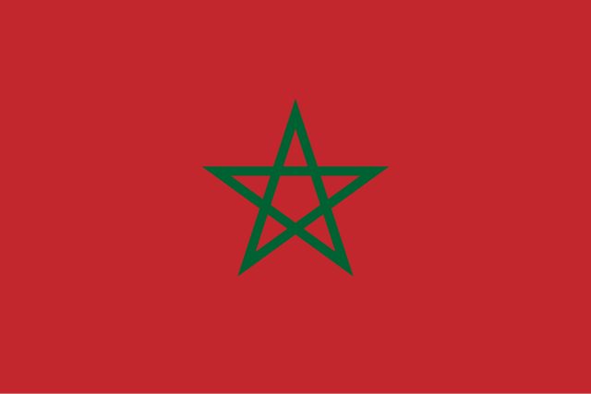

Country: Morocco

Committee: UNFCCC

Agenda item: Increasing the Use of Renewable Energy Sources

Delegate: Zeynep Sare YILDIRIM

Morocco has a long coastline. It starts from the Atlantic Ocean, and goes around the Strait of Gibraltar, and ends in the Mediterranean Sea. Morocco has 37 million population and it has many beautiful tourist attractions. The topic I will talk about is the increase in the use of renewable energy sources in Morocco. Using renewable energy is very important. So, what is renewable energy?

Renewable energy comes from natural sources. It can be used again after being consumed and does not harm the environment. Some examples of renewable energy are hydroelectric, geothermal, solar, wind, and wave energy. So, where can we produce these energy sources? Morocco is a hot country with an average of 3,000 sunny hours each year. Solar energy is a very good option because of so many sunny days. To use wind and wave energy, we can use the Atlantic Ocean because Morocco has strong wind and waves. Morocco wants to use more renewable energy to reduce its dependence on other countries.

In our opinion, using renewable energy will help the country develop and become more independent. It will also protect the environment and reduce global warming.