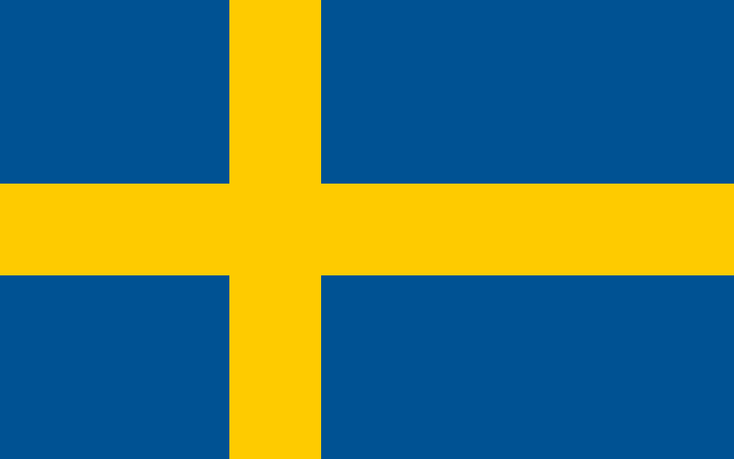

Country: The Kingdom of Sweden

Committee: The Economic and Social Council (ECOSOC)

Agenda Item:Promoting green jobs and the transition to a green economy

The Kingdom of Sweden is located on the Scandinavian Peninsula in northern region of Europe.  The nation is bordered by three countries: Norway (to it’s north and West), Finland ( to it’s east), Denmark(via a bridge-tunnel through Öresund.)  Accordingly, there are three borders of Sweden namely the Sweden-Denmark border, the Sweden-Finland border, and the Sweden-Norway Border. The capital of country is Stockholm. The official language of the country is Swedish. The Swedish krona(SEK) has been the currency of The Kingdom of Sweden since 1873. The currency was introduced as a result of the Scandinavian Monetary Union with Norway and Denmark, which lasted until World War I. It is issued by the Swedish central bank Sveriges Riksbank. The symbol of the currency is kr. The country is temperate in south with cold, cloudy winters and cool, partly cloudy summers; subarctic in north. The population of the country is in total  10,589,835 (male: 5,332,701; female:  5,257,134) The ethnic groups in the country are: Swedish 79.6%, Syrian 1.9%, Iraqi 1.4%, Finnish 1.3%, other 15.8%. Most Swedes live in the south where the climate is milder and there is better connectivity to mainland Europe; population clusters are found all along the Baltic coast in the east; the interior areas of the north remain sparsely populated.

The current issues in The Kingdom of Sweden are marine pollution (Baltic Sea and North Sea); acid rain damage to soils and lakes; air pollution; inappropriate timber harvesting practices. And the country is trying to solve these problems in many ways.

Green jobs are jobs that help businesses reduce their environmental impact and provide economic benefits sustainable levels Green jobs cover agriculture, services, industry and many other areas government business; and has an important role in protecting and restoring the environment. Green jobs help: to improve energy and raw materials efficiency, to limit greenhouse gas emissions, to minimize waste and pollution, to protect and restore ecosystems, to support adaptation to the effects of climate change. Climate change is one of the most pressing issues of our time, and transitioning to a green economy is essential for dealing with its effects. Climate change is one of the foremost global environment problems today. The Swedish government has set ambitious goals for sustainability, including going fossil-free by 2045 and 100 per cent renewable energy. Green jobs help us face climate change by reducing greenhouse gas emissions, conserving resources, and promoting sustainable practices. Green jobs can drive economic growth by creating new industries and market opportunities. As the demand for renewable energy, eco-friendly products, and sustainable practices increases, green jobs will continue to expand and provide a stable source of employment. The green economy is under active development around the world, as sustainable growth is an emphasis by countries amidst the dual challenges of environmental degradation and economic inequality. In such initiatives, the European Union's Green Deal features as a flagship programme, aiming to transform Europe into the first carbon-neutral continent by 2050. In 2015, the world agreed on [17 sustainable development goals](https://sustainabledevelopment.un.org/?menu=1300), aimed at creating a better and fairer world by 2030. Sweden still has some way to go, but current innovations show that safeguarding our environment and developing society are part of the same challenge. Sweden’s reputation as an environmental pioneer began more than half a century ago. In 1967: Sweden became the first country to establish the environmental protection agency Naturvårdsverket.In 1972: Sweden hosted the first UN con­ference on the environment, which led to the creation of the [United Nations Envi­ronment Programme](http://www.unep.org/) (UNEP), the leading global environmental authority to this day. In 1995: Sweden was one of the first countries to introduce a carbon tax, which has helped reduce depend­ency on fossil fuels. In 1998 and 2002: Sweden was one of the first na­tions to sign and ratify the international climate change treaty [Kyoto Protocol](https://unfccc.int/kyoto_protocol). In 2001: [The Stockholm Convention](http://chm.pops.int/TheConvention/Overview/TextoftheConvention/tabid/2232/Default.aspx), largely a Swedish initiative, was a global treaty aimed at phasing out the production and use of persistent organic pollutants. In 2017: Sweden ranked third in the [Global Cleantech Innovation Index](http://info.cleantech.com/WWF-Index-2017_WWF-Index-2017-Submit.html). In 2020: Sweden ranked second in the [Global Innovation Index](https://www.globalinnovationindex.org/Home) and topped the [Global Sustainable Competitiveness Index](http://solability.com/the-global-sustainable-competitiveness-index/the-index).In 2021: Sweden ranked second in the [UN Sustainable Development Report](https://dashboards.sdgindex.org/#/SWE) and the [Global Innovation Index](https://www.globalinnovationindex.org/Home), and topped the [Global Sustainable Competitiveness Index](https://solability.com/the-global-sustainable-competitiveness-index/the-index). In 2022: More than 60 per cent of Sweden's electricity comes from renewable sources. In 2024: Sweden ranked second in the [Global Innovation Index](https://www.wipo.int/web-publications/global-innovation-index-2024/en/) – for the second year in a row. 2030 Goal: Sweden's transport sector is fossil-free. 2045 Goal: Goal: Sweden is fossil-free and, thus, climate-neutral.

Green economy is an economy that enhances human well-being and promotes social equity while minimizing environmental risks and resource shortages. Unlike the current dominant economic model which often increases inequalities and generates waste, this approach seeks to build a more sustainable, equitable, and healthy future. The Kingdom of Sweden has the world's first and most comprehensive carbon tax, which came into force in 1991; The country has been subsidizing electric vehicles since 2006; and reached its 50% renewable electricity target for 2020 eight years early. Sweden has the world's eleventh-highest GDP per capita, with an export-orientated economy based around high-value trade in engineering, telecoms, automotive and pharmaceuticals.

Turning trash into energy is Sweden’s one of the strategy.  Sweden has transformed the high-cost burden of waste into a profitable venture. The first efforts to convert waste to energy began as early as the mid-20th century with the implementation over time of a cohesive national recycling policy. This boosted recycling rates and placed the nation as a global leader in recycling.  
By converting its waste into energy, Sweden has reduced its carbon dioxide emissions by 2.2 million tonnes a year. Between 1990 and 2006, carbon dioxide emissions went down by 34%, and greenhouse gas emissions are projected to fall by 76% by 2020, compared to levels in 1990. Sweden has made recycling easy, accessible and convenient. A recycling station can be found within at most 300 meters from any residential area. And there are incentives: Swedish citizens get discount vouchers as a reward for using nearby recycling machines.

There are many countries making effort to promote green jobs and green economy. We hope that we will be rewarded for our efforts and celebrate the results together.

Delegate of The Kingdom of Sweden

Defne Demirel

Bibliography:

<https://european-union.europa.eu/principles-countries-history/eu-countries/sweden_en>

<https://www.worldatlas.com/articles/what-countries-border-sweden.html>

<https://www.oanda.com/currency-converter/en/currencies/majors/sek/#:~:text=The%20Swedish%20krona%20(SEK)%20has,of%20the%20currency%20is%20kr>.

<https://www.cia.gov/the-world-factbook/countries/sweden/#environment>

<https://www.britannica.com/place/Sweden>

<https://www.generation.org/news/the-importance-of-green-jobs-why-they-matter-and-how-to-get-started/>

<https://www.ilo.org/resource/article/what-green-job#:~:text=Green%20jobs%20are%20decent%20jobs,energy%20and%20raw%20materials%20efficiency>

<https://www.iberdrola.com/sustainability/what-are-green-jobs>

<https://greeneconomytracker.org/country/sweden#:~:text=It's%20no%20surprise%20that%20Sweden,renewable%20electricity%20eight%20years%20early>.

<https://www.blueoceanstrategy.com/blog/turning-waste-energy-sweden-recycling-revolution/>

<https://sweden.se/climate/sustainability/swedish-recycling-and-beyond>