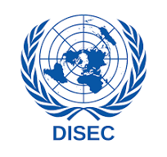
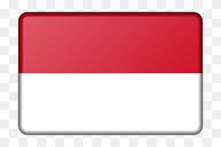
THE REPUBLIC of INDONESIA

Position Paper
Country: Indonesia
Committee: DISEC (Disarmament and International Security Committee)
Agenda Item: The Russia-Ukraine War and the Use of Weapons in International Law

Introduction
Indonesia, officially the Republic of Indonesia, is a Southeast Asian and Oceanian nation comprising over 17,000 islands, with the largest being Sumatra, Java, and Sulawesi, along with portions of Borneo and New Guinea. As a nation rich in natural resources, Indonesia's economy primarily relies on oil and natural gas, while most of its population sustains livelihoods through agriculture, animal husbandry, and fishing.
However, challenges such as a shortage of healthcare professionals, particularly in the disadvantaged eastern regions, and an evolving dual education system inherited from colonial times, reflect the complexities of Indonesia's developmental path. These internal challenges shape Indonesia's approach to global issues, emphasizing peace and stability as prerequisites for progress.
Position
As the G20 term president, Indonesia has condemned Russia’s attack on Ukraine as "unacceptable." However, it has refrained from taking a confrontational stance against Russia, acknowledging its role as an alternative power to balance China and the USA. Indonesia values independence in its foreign policy and views Russia as a distant ally in countering potential external interference in Southeast Asia.
In addressing the Russia-Ukraine conflict, Indonesia proposes a pragmatic and peaceful resolution plan:
- Ceasefire Agreement: Immediate cessation of hostilities by all parties to establish the groundwork for peace.
- Demilitarized Zones: Withdrawal of troops from forward positions by 15 kilometers in all directions, monitored by the UN to ensure neutrality and stability.
- UN Peacekeeping Deployment: Establishment of a UN contingent to oversee the demilitarized zones and foster trust between the conflicting parties.
Call to Action
Indonesia strongly believes that Russia and Ukraine must sign a comprehensive treaty that includes regional disarmament measures. Russia should alter its aggressive policies toward Ukraine, creating an environment conducive to peace. In turn, Ukraine would be less likely to respond with hostility, fostering mutual de-escalation and rebuilding trust.
Wars significantly disrupt essential services such as education, healthcare, and security, with severe long-term effects on national development. Indonesia emphasizes the urgency of peaceful negotiations to end human suffering and restore stability in the region.
Conclusion
Indonesia remains committed to promoting dialogue, supporting international law, and fostering cooperation to resolve the Russia-Ukraine conflict. Peace is not just a necessity but a foundation for global progress.

