daire, logo, simge, sembol, grafik içeren bir resim

Açıklama otomatik olarak oluşturuldu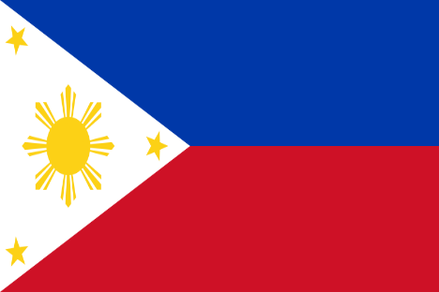 The Republic of Philippines  
**Committee**: DISEC (Disarmament and International Security Committee)  
**Country**: Philippines  
**Agenda**: The Russia-Ukraine War and the Use of Weapons in International Law

**Introduction**

The Philippines, an archipelago in Southeast Asia, has a rich and diverse history tracing back to early hominins, including *Homo luzonensis*, and the first modern humans of the Tabon Caves. By 2200 BC, the arrival of Austronesian settlers marked the beginning of advanced societies and cultural development. Today, the Philippines plays a strategic role in Southeast Asia, both politically and economically, while maintaining its commitment to peace, diplomacy, and adherence to international law.

**The Russia-Ukraine War and its Implications**

The Russian invasion of Ukraine on **February 24, 2022**, stunned the international community, including the Association of Southeast Asian Nations (ASEAN). Initially, the Duterte Administration adopted a policy of **neutrality**; however, recognizing the broader implications of the conflict, the Philippines firmly **condemned the invasion** and warned against its spillover effects in Asia.

The Philippines' position reflects two key concerns:

1. **Global Security**: The use of **weapons in violation of international law** in Ukraine, such as cluster munitions and incendiary weapons, undermines the integrity of the rules-based international order established by the United Nations.
2. **Regional Stability**: The ongoing conflict raises concerns about similar **rising tensions in the Taiwan Strait**, a matter of direct security interest for the Philippines and the wider Asia-Pacific region.

**Philippines' Position and Solutions**

The Philippines, as a peace-loving nation and advocate for international law, proposes the following actions to address the Russia-Ukraine war and prevent the unlawful use of weapons:

1. **Strengthening International Law Compliance**
   * The Philippines calls for all states to adhere strictly to the **Geneva Conventions** and other treaties governing the use of weapons, including bans on indiscriminate weapons such as cluster bombs and chemical weapons.
   * Support for **accountability mechanisms** such as the International Criminal Court (ICC) to investigate and prosecute war crimes related to illegal weapon use.
2. **Diplomatic Mediation and Peaceful Dialogue**
   * The Philippines encourages renewed multilateral diplomatic efforts, particularly through the United Nations, to negotiate a **ceasefire** and facilitate peaceful dialogue between Russia and Ukraine.
   * ASEAN and similar regional organizations can serve as platforms to foster peace and prevent escalation.
3. **Regional Preparedness and Collaboration**
   * The Philippines underscores the importance of **regional cooperation** in Asia to ensure preparedness for any potential geopolitical spillover effects.
   * The Philippines reaffirms its security partnership with its formal treaty ally, the **United States**, to protect regional stability and sovereignty.

**Conclusion**

The Philippines strongly advocates for a peaceful resolution to the Russia-Ukraine conflict and calls for strict adherence to international law governing the use of weapons. The crisis serves as a reminder of the importance of multilateralism, diplomacy, and cooperation to maintain global security and prevent similar conflicts from escalating in Asia and beyond.

The Philippines remains committed to upholding the principles of peace, justice, and international law as enshrined in the United Nations Charter.