daire, logo, simge, sembol, grafik içeren bir resim

Açıklama otomatik olarak oluşturuldu**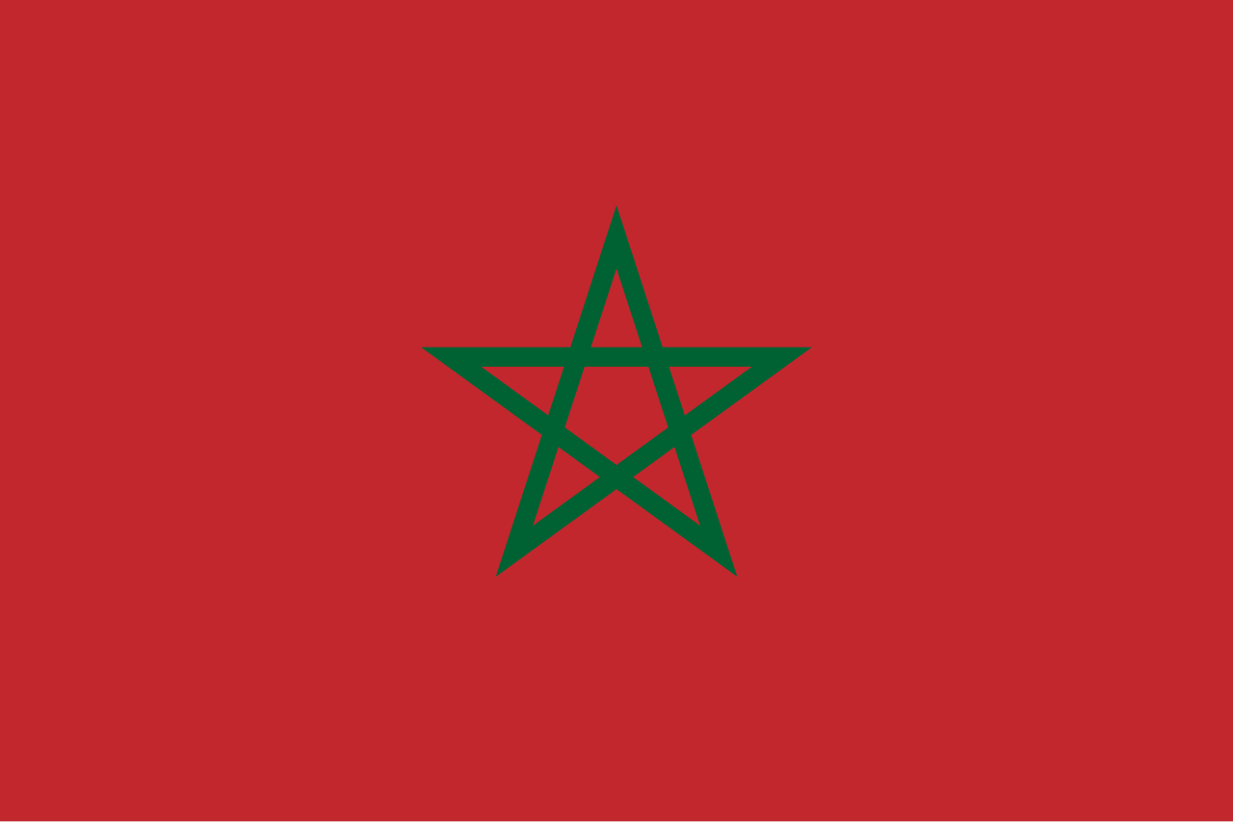 THE KINGDOM OF MOROCCO**

**Country:** Kingdom of Morocco  
**Committee:** DISEC (Disarmament and International Security Committee)  
**Agenda Item:** The Russia-Ukraine War and the Use of Weapons in International Law

**Introduction**

The Kingdom of Morocco, situated in the Maghreb region of North Africa, borders the Mediterranean Sea to the north and the Atlantic Ocean to the west, sharing land boundaries with Algeria to the east and the disputed territory of Western Sahara to the south. Morocco also claims the Spanish exclaves of Ceuta, Melilla, and Penon de Velez de la Gomera, along with several small Spanish-controlled islands off its coast. With a population of approximately 37 million, Islam serves as the official and predominant religion. The official languages are Arabic and Berber, alongside widespread use of French and the Moroccan Arabic dialect. Morocco’s culture reflects a blend of Arab, Berber, African, and European influences, with Rabat as its capital and Casablanca as its largest city.

**Position**

Morocco maintains a neutral stance in the Russia-Ukraine conflict. The Minister of Foreign Affairs, Nasser Bourita, has reiterated Morocco's commitment to the principles of territorial integrity, sovereignty of nations, and adherence to international law. From the onset of the crisis, Morocco has emphasized:

* Respect for legality and international law.
* Avoidance of force for conflict resolution.
* Support for dialogue and adherence to relevant UN resolutions.

Morocco views the Russia-Ukraine conflict as a destabilizing factor for regional security and global economic stability. While Morocco maintains positive diplomatic relations with both Russia and Ukraine, it promotes peaceful negotiation as the path to resolving this crisis.

**Proposals**

1. **Humanitarian and Territorial Peace:**  
   Morocco calls for immediate measures to restore regional stability and security. Addressing the humanitarian crisis and mitigating territorial disputes through UN-led dialogue is essential for global peace.
2. **Economic Perspective:**  
   Morocco highlights the economic repercussions of the conflict, including global inflationary pressures that impact countries like Morocco. It stresses the urgency of a peaceful resolution to stabilize oil prices and mitigate inflation's adverse effects worldwide.

**Conclusion**

At the geopolitical level, Morocco's diplomacy embodies a commitment to maintaining a sovereign and independent foreign policy. Its approach is rooted in a peaceful, pragmatic, and humanitarian perspective. Morocco stands ready to support dialogue and international cooperation to resolve the Russia-Ukraine conflict, ensuring respect for international law and promoting global stability.