POSTION PAPER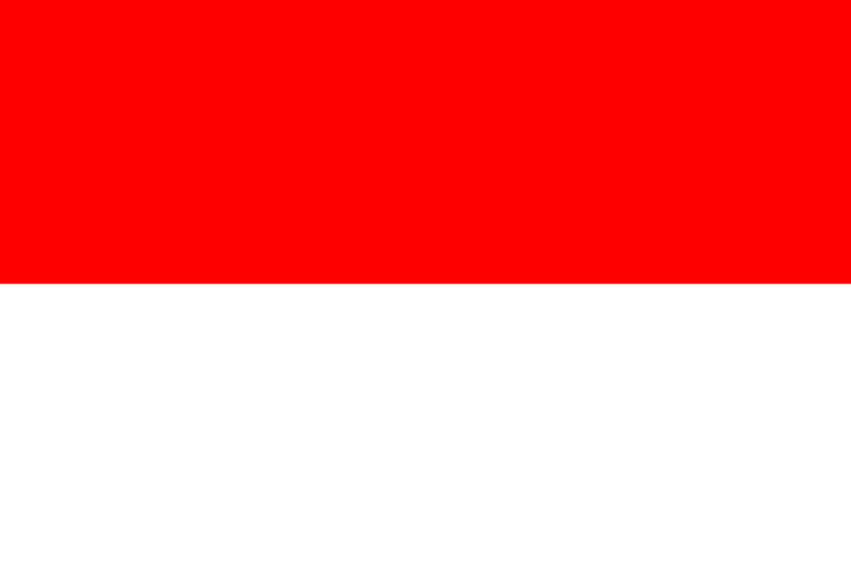

Country:Indonesia

Comitee:DISEC(Disarmament and International Security Comitee)

Agenda Item:The Russia-Ukraine War And The Use Of Weapons In International Law

Indonesia, officially the Republic of Indonesia, is a country located in Southeast Asia and Oceania, between the Indian and Pacific oceans. It consists of more than 17 thousand islands. The largest of these islands are Sumatra, Java and Sulawesi, and partly Borneo and New Guinea.   
Indonesia's economy is primarily based on oil and natural gas. However, the livelihood of the majority of the people is agriculture, animal husbandry and fishing. It is stated that there is a shortage of healthcare workforce in Indonesia. The eastern regions of the country are more disadvantaged in terms of lack of healthcare workers. It is stated that there is a lack of medical personnel and specialists in hospitals, and that it is not possible to find specialist physicians in basic branches in some of the hospitals. Republican governments, which inherited the style of education that developed during the colonial period, had to adopt a dual system in education in order to raise the education level of the people. One is the Western type education, which is based on the old Dutch education system and has changed over time, and the other is the modern education system in schools called madrassas, which also includes physical education

Indonesia, which holds the G20 term presidency, describes Russia's attack on Ukraine as "unacceptable" but refrains from taking a direct stance against Russia. One of the main reasons for this is that Indonesia sees Russia as an alternative power to China and the USA. Russia is a distant ally of Indonesia, which distrusts China and the United States for fear of interference in its internal affairs and is trying to establish an independent leadership in Southeast Asia. Regarding the proposed peace plan, Subianto said:

"First: a complete ceasefire by all parties to the conflict and the cessation of the enemies and the fixing of the posts in which they are currently located. Second: the withdrawal of troops from forward positions by 15 kilometers in all directions and their removal from a demilitarized zone. The deployment of the UN contingent throughout the demilitarized zone should be ensured. "

According to us,Russia and Ukraine must sign a treaty.In this treaty Russia and Ukraine must disarmament for some region(For their countries in their region).Russia must change its hostile policy towards Ukraine.In this way Ukraine would also not act hostile towards Russia. I think peacefully because people suffer a lot in wars (both in terms of education, health and security) and this negatively affects the development of countries.