 **Green Economy-ECOSOC** 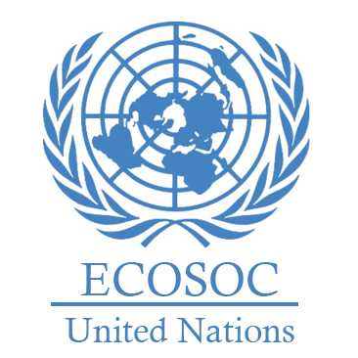

**Name:** Berra İnci Çevrük

**School/University:** Eryaman Doğa Collage

**Committee:** Ecosoc

We are very successful in managing waste. Most of our waste is recycled or turned into compost. We invest a lot in using solar and wind energy.

We support renewable energy and energy-saving buildings. In new construction projects, we use eco-friendly materials like recycled wood and natural insulation. We also encourage green building designs, such as rooftop gardens, like the green roofs in Brussels and green corridors in Antwerp.

As one of the leading countries in the field of green economy, we have adopted policies aimed at sustainable development under the European Green Deal. Through environmentally friendly practices and innovative approaches, our economy is undergoing a transformation while maintaining social and ecological balance.

We produce significant amounts of clean energy through wind farms located in the North Sea. Additionally, by promoting the widespread use of solar panels in cities, we contribute to the green economy.

We are taking various measures to enhance energy efficiency and reduce dependency on fossil fuels. These measures include maintaining low tax rates on electricity and natural gas, promoting energy-saving policies in public institutions, and increasing the tax rates on energy companies. Additionally, extending the operational lifespan of nuclear power plants is planned to ensure their longer presence in the grid

Our goal is to have zero carbon emissions by 2050 and to reduce emissions by 55% by 2030. We also aim to cut greenhouse gas emissions by 60% by 2030.

We plan to charge taxes based on carbon pollution. To fight climate change, we add green areas in flood zones and improve farmlands.

In the Flanders region, we have advanced waste management systems. For example, in 2015, we produced about 360,000 tons of compost.

We also make more energy with wind farms in the sea and build energy-saving homes in cities.

We believe that the importance of the green economy will increase