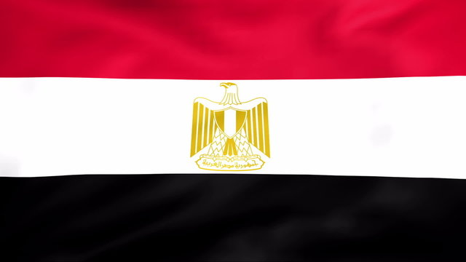

Conference: Hacettepe University Training Conference 2024

Committee: Food and Agriculture Organization

Topic: Strategies for Advancing Sustainable Agricultural Practices in the Green Transition

Country: Egypt

Delegate: Melek Sena ALTINOK (MERMUN delegation)

The agricultural sector plays a critical role in the world economy. It provides employment to a significant part of the jobs performed in the world and contributes to the gross domestic product of many countries. However, traditional agricultural practices such as intensive spraying and intensive use of artificial fertilizers, corrupt culture and large-scale industrial agriculture have negatively affected the environment, public health and food security worldwide. Sustainable agriculture offers a viable solution to get rid of these troubles and negative effects. It provides a path towards a more flexible, equitable, widespread and globally sustainable food and agricultural system that benefits everyone in the world. According to the Food and Agriculture Organization of the United Nations (FAO), unsustainable agricultural practices are responsible for 70% of global freshwater withdrawals and 80% of worldwide deforestation. In order to find solutions to these problems urgently, sustainable agricultural practices in the world should be accelerated.

Unfortunately, as Egypt is on the path of development and as a country that is doing this, our population and financial resources do not allow us to work at the cutting edge of green research. but by adopting green technologies and preparing studies that we can use them, we can contribute to this project. We expected our sectors to support us for the growth of this project. But for some sectors, they don't want to approach this strategy because they think it could disrupt the situation they are in and their economy. This is usually the case for our agricultural sector, which is around the Nile River.. We expect the agricultural sector in Egypt to leave 1.8 million people by 2060, and this makes us very sad. For our other sectors, we aim to direct them with efforts to increase their growth, and we definitely support them. This means that we aim to generate 42% of our country's energy demand from renewable energies by 2035, and this can be observed more or less in our sustainable energy strategy.

We would like to offer a few solutions against this. The first is to make efforts to ensure the development of green technology in traditional sectors. Although our country has advanced the energy sector in the last 10 years, it is still weak in terms of green space. Our government should take the structure of different sectors and countries as an example, abandon traditional methods, settle into modernity and move forward accordingly. Secondly, it is a great starting point that most of our Egyptian people believe that climate change is happening, that it is starting to have an impact and that they are aware of the bad consequences that this can cause. Awareness campaigns focusing on the causes of climate change, we need to bring this to the forefront a little bit to make them more relatable. And finally, institutional and financial supports aimed at developing the green skills of our Egyptian people, and we plan to encourage enterprises to develop the green skills of current and future employees, either directly through education and training or indirectly.

*Bibliography*

# 7 ways to accelerate the transition to sustainable agriculture, Apr 25, 2023 <https://www.weforum.org/stories/2023/04/7-ways-to-accelerate-the-transition-to-sustainable-agriculture/>

“GE-TOP Report: Green Economy and Trade – Trends, Challenges and Opportunities,” United Nations Environment Programme, accessed January 19, 2023, <https://www.unep.org/explore-topics/green-economy/what-we-do/environment-and-trade-hub/green-economy-and-trade-1.>

Joel Smith, Leland Deck, Bruce McCarl, Paul Kirshen, James Malley, and Mohamed Abdrabo, *Potential Impacts of Climate Change on the Egyptian Economy* (Cairo, Egypt: United Nations Development Programme (UNDP), 2013), 91, <https://www.undp.org/sites/g/files/zskgke326/files/migration/eg/01_Potential-ImpactofCConEgyptianEconomyEnglish.pdf.>

“Electricity and Renewable Energy,” International Trade Administration, August 8, 2022, <https://www.trade.gov/country-commercial-guides/egypt-electricity-and-renewable-energy.>

Egypt’s Green Transition: Nurturing A Sustainable Economy and Workforce, Policy Note, July, 2023 <https://mecouncil.org/publication/egypts-green-transition-nurturing-a-sustainable-economy-and-workforce/>