COUNTRY: SERBIA 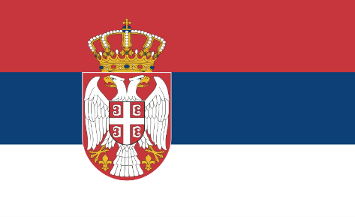
COMMITTEE: UNDP
TOPICS: STRENGTHENING THE INTEGRATION OF CRISIS RESILIENCE SYSTEMS WITH PEACEBULDING INITIATIVES AND CONFLICT PREVENTION STRATEGIES

Serbia has made great efforts to maintain peaceespecially during the conflicts in the Balkans.Serbia has taken steps to contribute to peacebuilding interventions in various areas such as diplomatic, political, and military, both regionally and internationally. Even tough Serbia has made many efforts for peace, it’s policy of not recognizing Kosovo’s independence has created tensions.

Initially, there were no relations between Kosovo and Serbia, but dialogue and cooperation between the two sides have increased in the following years. Kosovo, where the majority population is ethnic Albanian, declared independence in 2008. Serbia does not recognize Kosovo’s independence and considers it part of its territory, although it is not formally under its control. Negotiations facilitated by the European Union resulted in the Brussels Agreement on normalizing relations between the governments of Kosovo and Serbia. The agreement pledged that both sides should not obstruct the other in the EU accession process. However, Kosovo is currently recognized as an independent country by 18 UN member states. In total,113 UN member states have recognized Kosovo at some point, and 15 of these have subsequently withdrawn their recognition.

In addition, Serbia can play a more active role with the European Union and the United Nations to solve its problems with Kosovo. To strengthen peace in the Balkans, we can take steps based on dialogue, reconciliation, economic development, and human rights. By cooperating with other countries in the region. Serbia can heal the wounds of the past and look at the future with hope.

