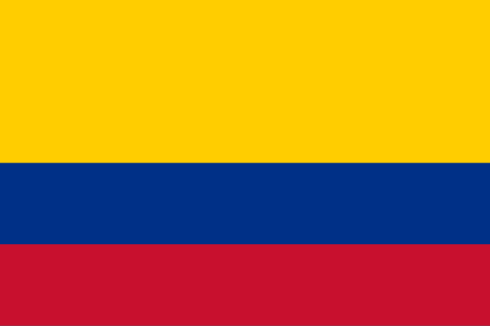

Country: Colombia

Committee: The Economic and Social Council (ECOSOC)

Delegate: İlsu Ayşem TUNA

Topic: Promoting Green Jobs and The Transition to a Green Economy

The population of Colombia is 52.09 million. The currency is Colombian Peso, which is located in South America. Neighborhood; It is bordered by Panama to the northwest, the Caribbean Sea to the north, Venezuela and Brazil to the east, Ecuador and Peru to the south, and the Pacific Ocean to the west. The capital of Colombia is Bogotá, the official language is Spanish, and it is the second most populous Spanish-speaking country in the world, after Mexico.

Colombia's history began when the country was ruled by white people from Spain until the 18th century. The fight for independence started, and the North American and French Revolutions made the country stronger. In 1808, when Napoleon invaded Spain, the Spanish colonies in America began fighting for independence. Because of this, Simón Bolívar's forces declared independence in Cartagena, and in 1821, they created a federation called Gran Colombia, which included today’s Colombia, Ecuador, Panama, and Venezuela.

Colombia is the second country in the world with the most biodiversity, after Brazil. The country has many different areas, such as Amazon rainforests, mountains, grasslands, and deserts. It is the only country in South America with coasts on both the Atlantic and Pacific Oceans.

Colombia is a regional power and has the third largest economy in South America. The main industries are coffee, flowers, emeralds, coal, and oil. Colombia is a member of the United Nations, World Trade Organization, OECD, Organization of American States, Pacific Alliance, and Andean Community. It is also a global partner of NATO.