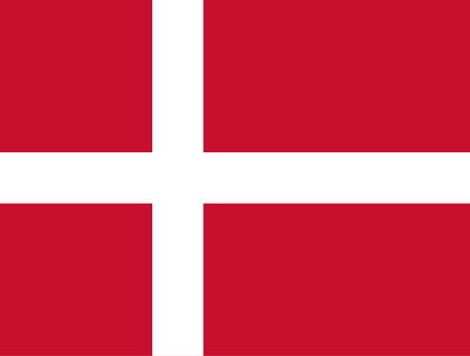

Country: Denmark
Committe: ECOSOC (Economic and Social Council)
Agenda Item: Promoting Green Jobs and the Transition to Green Economy

Denmark is a Nordic country in Northern Europe. It also known as Kingdom of Denmark and Dannish Realm. The capital city is Copenhagen, official language is Dannish. Denmark is a constituonally unitary state that includes the Faroe Islands and Greenland in the north Atlantic Ocean. The populatiton is 5,916 million by 2023. The workforce in the country is really developed. Unemployment rate is between %2-%3. This a reflection of a advanced economy by the results of proven by GDP. The country is a member of European Parliament, Council of the EU, Presidency of the Council of the EU, European Commission, European Economic and Social Committee, European Committee of the Regions, Permanent represantation to the EU.

Agenda Item: Promoting Green Jobs and the Transition to Green Economy

Green economy is a idea that aims ensuring of future generations needs by keeping the balance between environment and economy. Green economy protects the environment quality, reduces degradatiton of ecosystems and also stimulates economic growth and employment. In today’s world, where resource shortages increase, the importance of sustainability increases day by day. We may able to turn natural resources (solar, wind, wave, geothermal etc.) into energy. Denmark is building a strong job market at home while allowing it to share knowledge in developing wind projects around the world, it has made it leader. Denmark sees itself as committed to developing sustainability goals every year.

Green economy implementing wants a strong economy and Denmark can providing it. Denmark has a binding act that compels to reduce their greenhouse gas emissions by %70 by 2030. Denmark aiming an entirely climate neutral country by 2050. Implements fort his aim has started in 1970s. Denmark made history by erecting the world’s first offshore wind farm in 1991. Danish parliament set ambitious targets regarding green power generation and CO2 reductions.

Denmark’s current solutions for improving green economy and green jobs for our world and future:
- Denmark mainting a strong focus on energy efficiency and massively exponding renewable energy generation by building energy islands connected to thousands of offshore wind turbines. And it began trading electricity with our Nordic neighbours.
- Denmark implementing a new, comprehensive CO2 tax and decarboning our industries, including transportation and shipping, via green fuels.

Denmark is on the way to becoming a climate neutral society as soon as possible. It plays and active role in committe and promotes global partnerships to combat climate change. Together, we can achieve a healthy environment and leave a clean future.

References

- https://www.zorlu.com.tr/akillihayat2030/yazilar/surdurulebilir-enerji-nedir-temiz-enerji-kaynaklari-nelerdir#:~:text=S%C3%BCrd%C3%BCr%C3%BClebilir%20enerji%20veya%20di%C4%9Fer%20ad%C4%B1yla,olmayan%20enerji%20kaynaklar%C4%B1n%C4%B1%20ifade%20eder.
- https://en.wikipedia.org/wiki/Denmark
- https://www.youtube.com/watch?v=2hqD63t0UnI

