Position Paper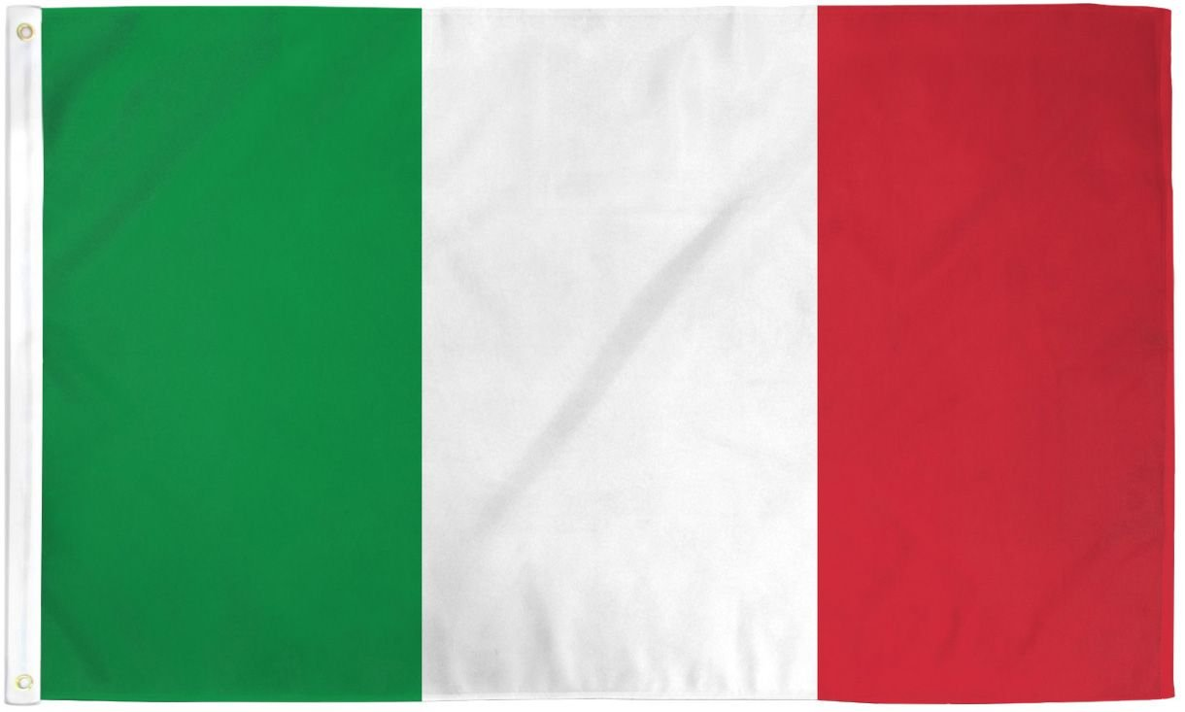

Delegate: Muhammed İkbal Şakiroğlu

Country: The Italian Republic

Committee: North Atlantic Treaty Organization

Agenda Item: Potential NATO Measures To Counter

The Growing Danger Posed By The Eastern Bloc

Italy is a European country located at central mediterranean. Italy shares its borders with France, Switzerland, Austria, Slovenia, and two enclaves: Vatican City and San Marino.Italy is the tenth largest country at Europe and has 60 million population. The capital city of Italy is Rome. Italy’s current leader is Giorgia Meloni (First women prime minister of Italy) and they have unitary parliamentary republic system. The official language is Italien. Italy has district polices against refugees.

Italy is a member of North Atlantic Treaty Organization since 1949. Italy is a major participant to North Atlantic Treaty Organization’s military command. It has provided personnel and resources to operations, and several senior NATO military officers have been Italian.

Italy has been a strong participant for European security and defense cooperation within NATO. While it supports NATO’s transatlantic bond, Italy has also pushed for closer cooperation between NATO and the European Union (EU), particularly in areas such as crisis management, cyber defense, and counter-terrorism.

Italy is part of NATO’s nuclear sharing arrangements, meaning that it hosts U.S. nuclear weapons as part of the alliance’s collective defense strategy. Italy’s air force operates aircraft capable of delivering nuclear weapons in a potential conflict, further integrating Italy into NATO’s nuclear deterrence framework.

References Links:

<https://en.wikipedia.org/wiki/Italy>

<https://www.cia.gov/search/?query=Italy&site=the-world-factbook>

<https://european-union.europa.eu/principles-countries-history/eu-countries/italy_en>