Country: Greece  Committee: Food and Agriculture Organization (FAO) | 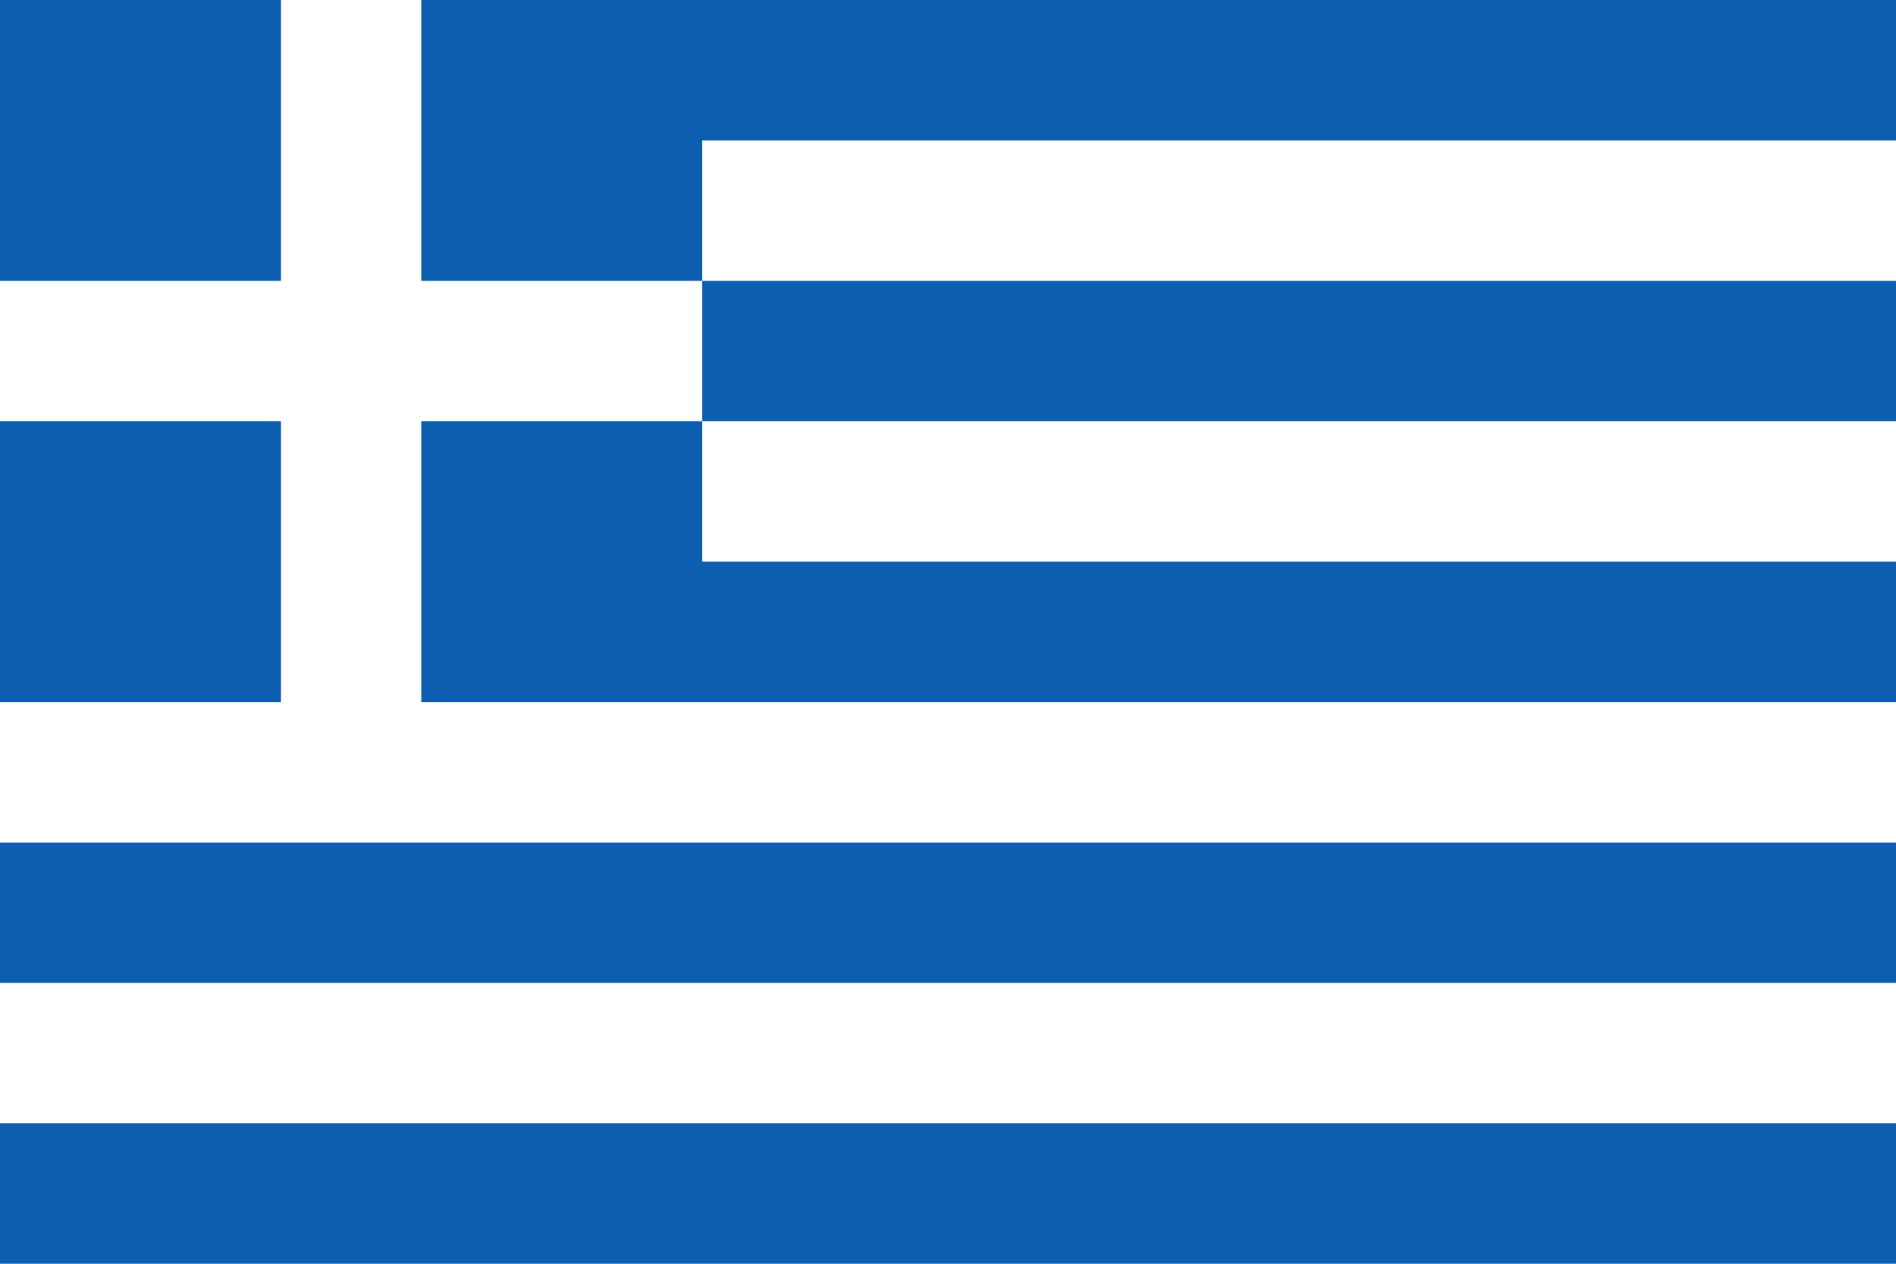

Rising temperatures, irregular rainfall, natural disasters and desertification have severely affected the global agriculture. As a Mediterranean country, Greece has an important role in food production and the country’s income sources, including soil degradation, water shortage and loss of biodiversity that endanger, livelihoods. Greece has experienced the effects of climate change closely. Greece's agricultural potential is hampered by poor soil, inadequate levels of precipitation, a landholding system that has served to increase the number of unproductive small holdings and population migration from the countryside to cities and towns. Less than one-third of the land area is cultivable with the remainder consisting of pasture, scrub and forest. And also, Greece became an official FAO member country in 1945.

Greece has invested in promoting organic farming and efficient irrigation systems to increase long-term agricultural productivity. It also contributes greatly to preventing soil erosion. Greece supports international agreements such as the Paris Agreement. One of the issues that Greece attaches importance to is reducing food waste and ensuring efficient food production and consumption. Since it's a seaside country and derives the majority of its income from here, Greece prioritizes the protection of the marine ecosystem in order to ensure food security.

Greece’s recommendations for more sustainable and reliable agriculture are as follows. We must implement advanced irrigation systems to prevent water scarcity, and we should make periodic irrigation devices more widespread. We must invest in drought resistant products. We can develop technology to facilitate developing countries access to sustainable agriculture. We can provide financial resources and technical training to encourage farmers. We can ensure compliance with the hunting ban in fishing. To protect soil health, we must reduce the use of chemicals, use natural fertilization and compost and use water in a balanced manner. In this way the nutritional value of the soil increases.

Finally, Greece attaches importance to issues such as sustainable agriculture, food security and environmental protection. We call on all member states to work collaboratively share best practices and support innovation.

Thank you.
Deniz Çetin

