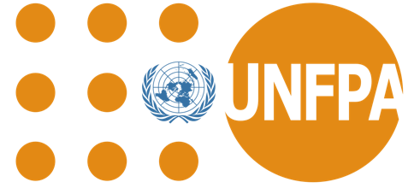

Country: Nigeria

Committee: UNFPA (United Nations Population Fund)

Agenda Item: Global Health Strategies to Reduce Child Mortality

We work hard to reduce child mortality by addressing preventable causes such as malnutrition, malaria, diarrhea, and inadequate healthcare access. We collaborates with international organizations to implement vaccination campaigns, distribute insecticide-treated mosquito nets, and improve access to clean water and sanitation. Programs like the Basic Healthcare Provision Fund (BHCPF) aim to enhance maternal and child healthcare, especially in rural areas. Despite progress, challenges like weak healthcare infrastructure, population growth, and regional conflicts continue to hinder efforts. Strengthened policies and sustained investment are essential to further reduce child mortality in the country.

Nigeria has been working to reduce child mortality through various health, education, and infrastructure initiatives, both in the past and present. Child mortality in Nigeria is often caused by preventable issues such as malnutrition, malaria, pneumonia, diarrhea, and birth complications. The government, along with international organizations, has implemented numerous measures to address these challenges. We made significant strides in reducing child mortality through immunization, nutrition, and malaria control programs. However, sustainable progress will require continued investment in healthcare, education, and clean water infrastructure, as well as stronger governance and international support.

All those actions collectively, including improving access to healthcare, clean water, and sanitation, mass immunization campaigns, and nutrition intervention, are a prerequisite to saving the lives of children in Nigeria. Prenatal and postnatal care should be emphasized for mothers, while communities must also be educated on basic health practices and hygiene awareness, especially in rural areas. For instance, basic conditions should exist for fighting malaria, diarrhea, and pneumonia-like insecticide-treated mosquito nets and access to medicines and increased health facility base. International organizations will give more funding and use that money in strengthening the healthcare system; this will bring about a significant change in the norms of living conditions of children. When implemented on a large scale and sustainably, it can reduce child mortality in Nigeria.

References: <https://www.wikipedia.org/>