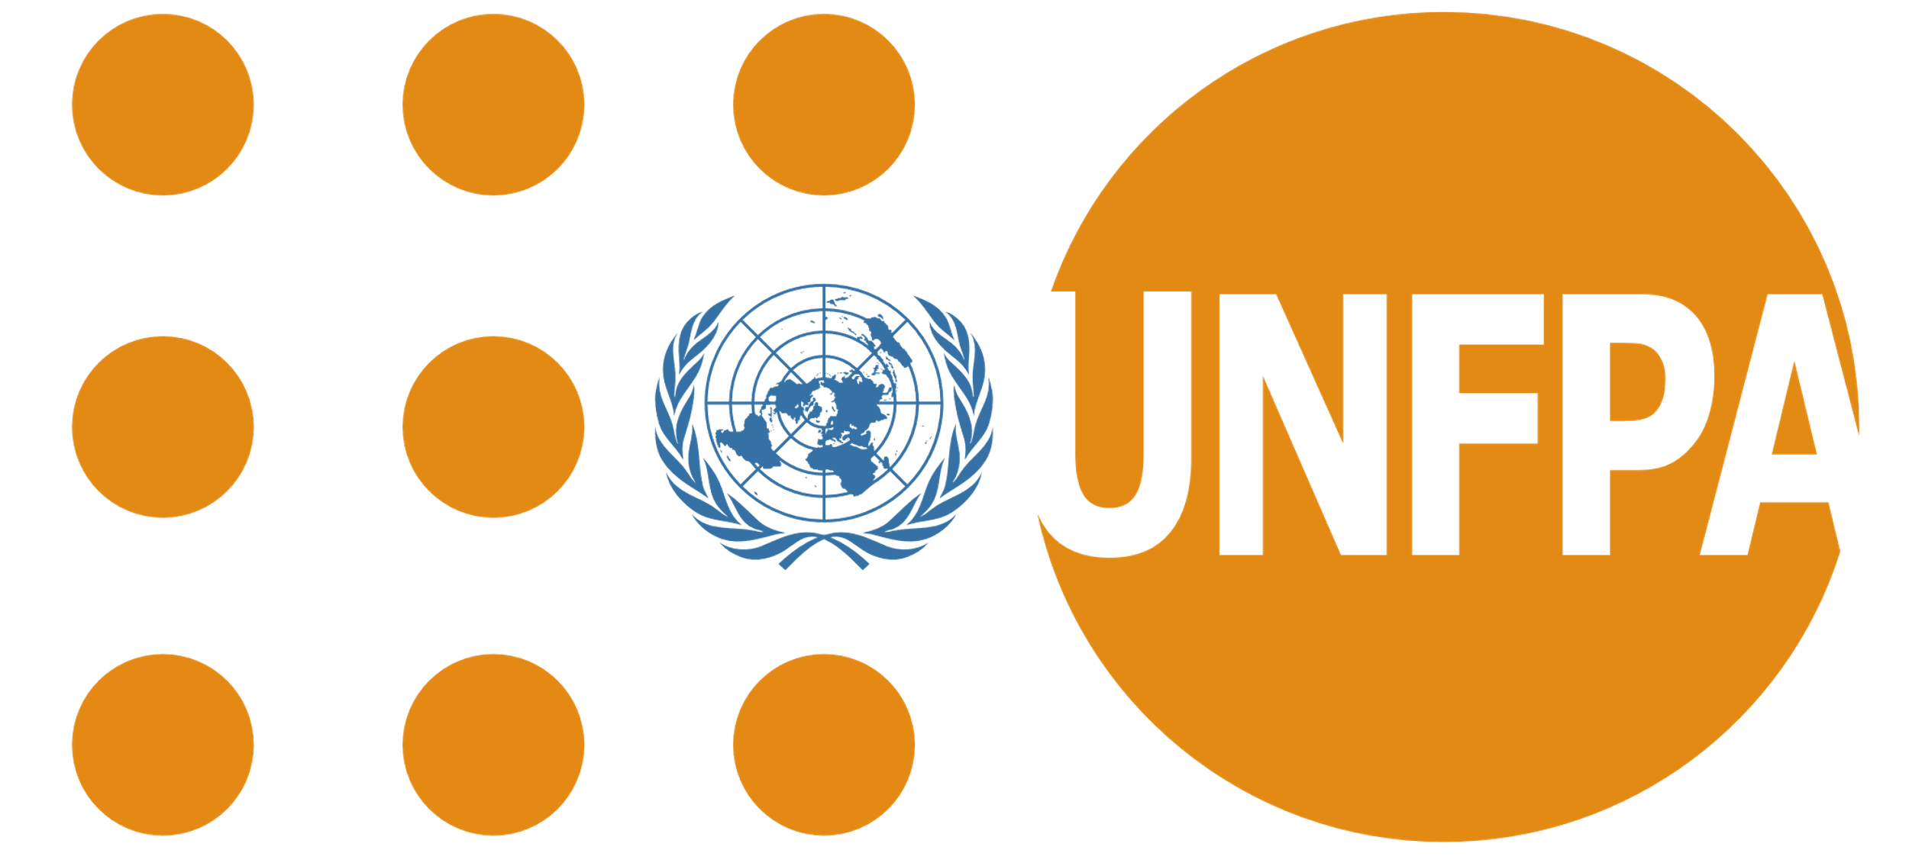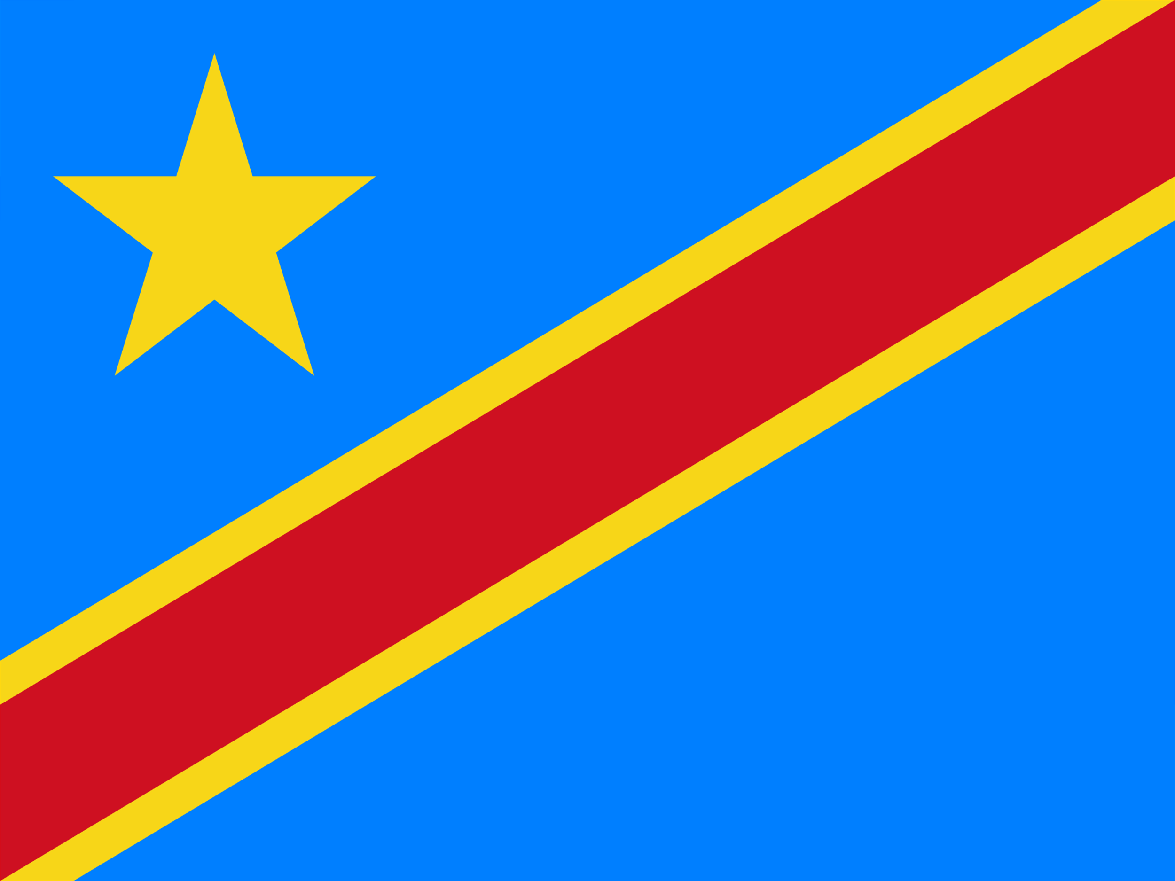

**Country : Democratic Republic Of Congo**

**Committees : UNFPA (Global Health Strategies to Reduce Child Mortality)**

**Agenda Item : Global Health Strategies to Reduce Child Mortality**

Our country is located in Central Africa, the second largest on the African continent. The capital, Kinshasa, which is also the most populated city, is an important economic pole for the country. It has considerable natural resources, among them cobalt, copper, and gold; however, because of internal conflicts and political instabilities, this wealth hasn't been managed properly or to the benefit of its people. The education and healthcare are also quite far from a favorable situation. Literacy rates are low, schools are underfunded, and healthcare services, particularly in rural areas, are limited. Diseases like malaria and HIV/AIDS are common.

Our country, with its large population and numerous challenges such as political instability, poverty, and inadequate healthcare, is heavily involved in international discussions on population and development. These issues often include high maternal mortality rates and limited access to family planning, which highlight our country's position as a significant player on the global stage. The United Nations addresses reproductive health and gender equality through resolutions like United Nations Resolution 2250 and the Cairo Programme of Action. This area attracts contributions from international partners, including the US, Canada, and the European Union, who focus on healthcare and the empowerment of women to promote national and regional stability.

Our country, just like other countries around the world, has a very high rate of child mortality. A few factors are affecting the situation: poor healthcare, lack of nutrition, low vaccination coverage, and unavailable sanitation. That is one of the elements to reduce the child mortality rate so that every child could have a healthier life. Our country is planning and carrying out child health care as its main focus. Among the possible ways to minimize the scourge of child mortality are the provision of primary health care services, campaigns on maternal and child health, as well as the strengthening of inoculation and nutrition programs. The strategy also consists of infrastructure improvement, health workforce training, and the elimination of malnutrition. The United Nations will be useful in the provision of financial and technical support, contributing to health programs as well as the increase in humanitarian aid used for places with conflict. These steps are the key milestones that may help the country achieve the objective of being a healthier society; thus, the mortality rate of children will be brought down.

References:

<https://dictionary.cambridge.org/>

<https://tr.wikipedia.org/wiki/Anasayfa>