 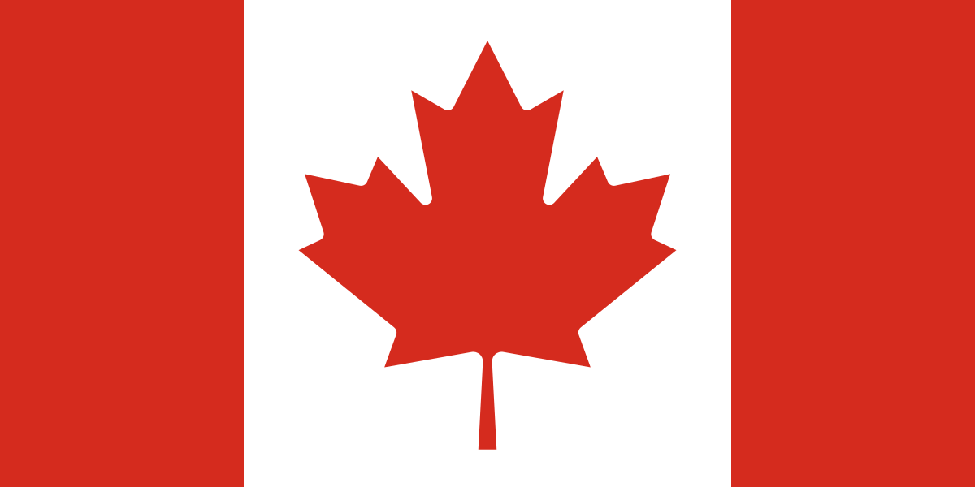

Committee : World Intellectual Property Organization

Country : Canada

Agenda : Protecting Young Entrepreneurs and Their Inventions Through Intellectual Property Rights

What Young Entrepreneurs Face

Young Entrepreneurs in our country mostly suffer from the lack of creativeness, time, energy, experience, responsibility, items and originality.

Their creations like arts, machines often get stolen by other people.Young Entrepreneurs have even more limited resources than other individuals.

IP Strategy

IP strategy is a systematic approach that organizations and individuals adopt to manage and leverage their intellectual property assets effectively. Inventions, literary, creative and artistic works, designs, logos, symbols and pictures utilized is commerce are all examples of IP.

Protection of IPR

IPRs here are protected by both federal statutes and common law with the goverment. Each type of IP is governed by a special law. Apart from secret and special business

To protect the rights of young entrepreneurs in our lands, various initiatives and policies have been implemented at both federal and provincial levels. These efforts focus on providing support, recourses and opportunities that empower young entrepreneurs and individuals to pursue entrepreneurship.

To restraint these obstacles; copyrights, patents and labels should be more normalized. Respecting and using the creations and rights will succor young entrepreneurs.

REFERENCES:

<https://en.wikipedia.org/wiki/Canadian_intellectual_property_law>

<https://www.wikipedia.org/>