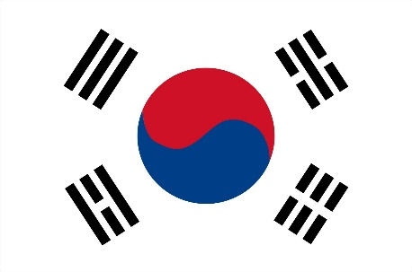 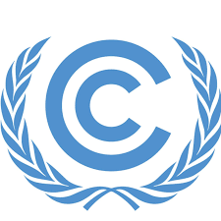

Committee: UNFCCC

Country: South Korea

Agenda Item: Increasing The Usage Of Renewable Energy In Developing Countries

Our country is located in East Asia, on the southern portion of the Korean Peninsula located out from the far east of the Asian landmass. We are the only country that shares a land border with North Korea with 238 kilometres . Having a landmass of approximately 100,364 square kilometres, 290 square kilometres of our country are occupied by water. Not only offering a blend of modern amenities, a rich cultural heritage, excellent healthcare, efficient public transportation, delicious cuisine, and a safe environment, we have affordable tuition fees, and a vibrant, safe atmosphere for students.

With a recycling and composting rate around 60% we are a global leader in sustainable waste management initiatives, policies encourage the use of renewable energy, reduce emissions, and invest in green infrastructure. Our largest single source of low-carbon electricity is nuclear with 29%, but its combined share of wind and solar is 5%. In 2021, We officially announced that we would cut our domestic emissions to a level 40% below 2018 levels by 2030. This is a significant improvement compared to our previous target of 24.4% below 2017 levels.

We are planning to generate 70% of our electric power from carbon-free energy sources such as renewables and nuclear power by 2038. Also by 2030, we aim to reduce our plastic waste by 50%, recycle 70% of it and increase the renewable electricity share to 21.6%. In 2020, we committed to achieving carbon neutrality by 2050.

The goals which we have already set by 2050 and we suggest to discuss are:

➊ Expanding the use of clean power and hydrogen across all sectors

➋ Improving energy efficiency to a significant level

➌ Commercial deployment of carbon removal and other future technologies

➍ Scaling up the circular economy to improve industrial sustainability

➎ Enhancing carbon sinks

References: <https://www.wikipedia.org/>

<https://delegatepal.com/>

<https://www.munturkey.com/news/>