bayrak, simge, sembol, sarı, grafik içeren bir resim

Açıklama otomatik olarak oluşturuldu United Nations 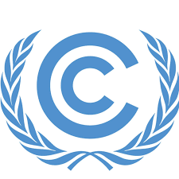 . Framework Convention on Climate Change

Commitee: United Nations Framework Convention on Climate Change (UNEFCCC)

Country: Ghana

Our country, located in West Africa, shares borders with Burkina Faso to the north, Togo to the east, and Côte d'Ivoire to the west, while the Atlantic Ocean forms our southern coastline. Although healthcare is provided with various programs designed to improve accessibility and quality of care, rural areas still often face challenges in obtaining adequate healthcare. While English is the official language, many local languages are widely spoken by ethnic groups.

We are optimising land use by building giant floating solar power plants on the Bui water reservoir These projects both increase energy production and reduce environmental impacts We aim to increase solar power generation capacity to 150 GW by 2060 We have approved the ‘Green Minerals’ policy to develop the lithium industry to transition to green energy This policy is considered an important step towards increasing renewable energy sources We also plan to make solar energy account for 83% of the country's total power generation capacity

We are also pursuing sustainable development initiatives to protect and responsibly manage our natural resources for future generations. The United Nations should continue its support for peacebuilding efforts and strengthen conflict resolution mechanisms in our country. Additionally, we encourage active participation in international security cooperation to promote regional stability and global peace.

**References:**

<https://delegatepal.com/>

<https://www.wikipedia.org/>