 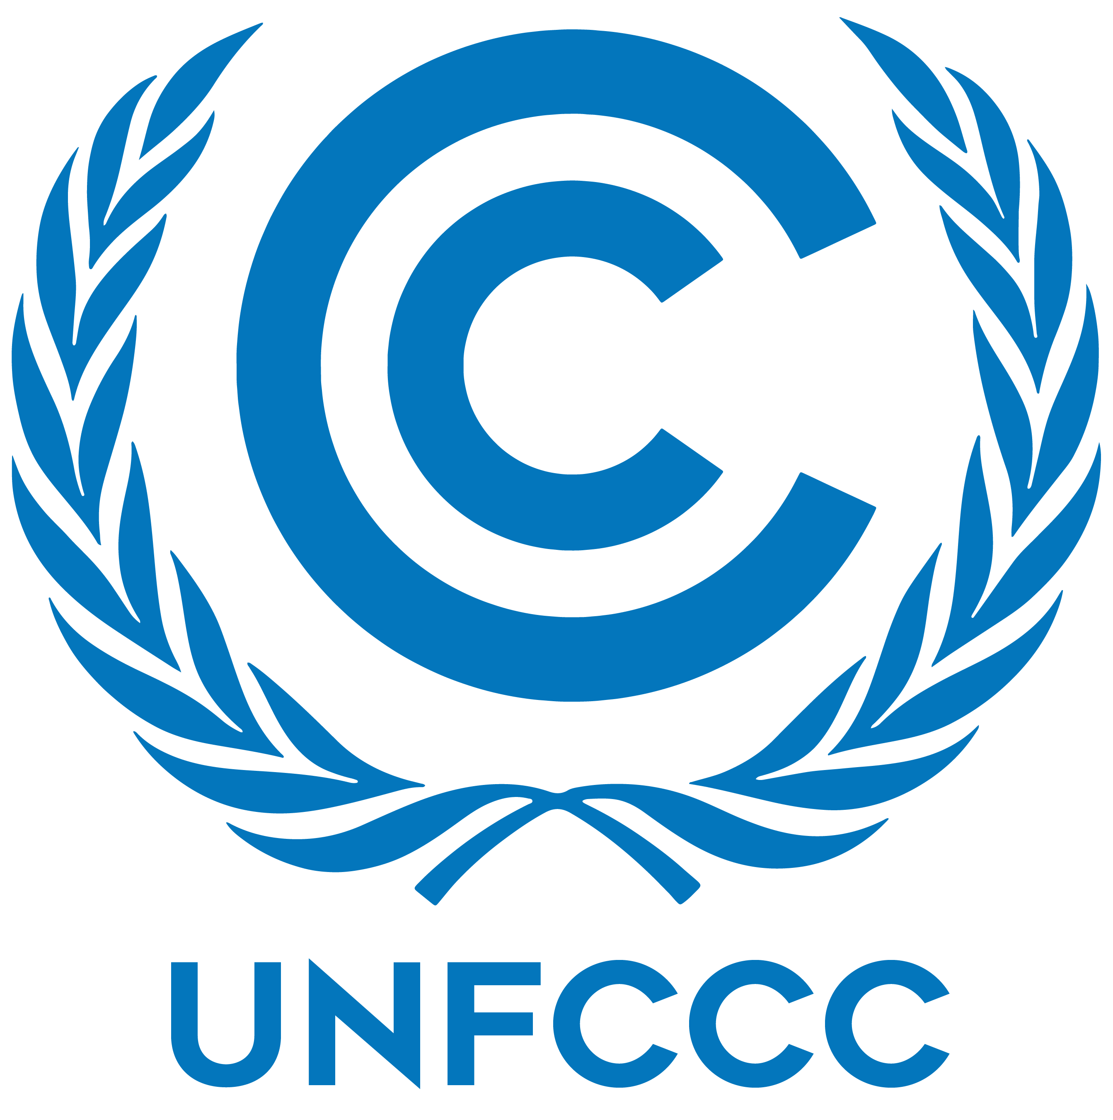

COUNTRY : Nigeria

Commitiee: UNFCCC (United Nations Framework Convention on Climate Change.)

We are a country located in West Africa. We are the most populous country in Africa and the seventh most populous country in the world with a population of about 206 million. The majority of our population is made up of indigenous tribes.

In the modern era, the factors causing the climate crisis include the burning of fossil fuels, deforestation and industrial activities. According to the United Nations, we have the highest rate of deforestation in the world.Every year, we lose about 3.7 percent of its forests. In addition to land use change and energy production,deforestation is a major source of greenhouse gas emissions. Rising temperatures are fueling environmental degradation, natural disasters, extreme weather, food and water insecurity, economic disruption, conflict and terrorism. Sea levels are rising, the Arctic is melting, coral reefs are dying, oceans are acidifying and forests are burning.

To prevent forest fires, we suggest that heat detectors could be installed in forests,. We updated its Nationally Determined Contribution (NDC) in 2021 in support of the United Nations Framework Convention on Climate Change Paris Agreement. The 2021 NDC update included emissions reductions from the waste sector for the first time, covered the water resources sector, and promoted other efforts to reduce emissions from agriculture, forestry, and land use. Finally, the Nigeria Energy Transition Plan outlines our commitment to carbon neutrality by 2060 across five key sectors—power, cooking, oil and gas, transport, and industry. Also The United States Agency for International Development (USAID) helps us for natural climate solutions and renewable energy sources. USAID contributes to achieving these targets through watershed protection efforts in Cross River and Bauchi states that maintain critical ecosystem services, including land-based greenhouse gas emissions reductions and carbon sequestration.

References:

<https://www.wikipedia.org/>

<https://delegatepal.com/>