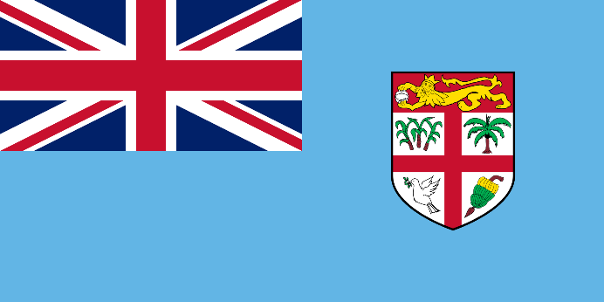Republic Of Fiji

Committee: The Special Political and Decolonization Committee (SPECPOL)

Country: Republic Of Fiji

Agenda Items: Establishing a Global Framework for the Protection of Stateless People

Fiji is an island country in Melanesia that has 322 islands and 522 islets. It’s located in the northeast of Australia, north-northeast of New Zealand. Suva is the capital of Fiji. Fiji’s economy relies on tourism. and sugarcane production. The population is diverse, with native Fijians (iTaukei) and Indian-origin communities living together. Fiji has problems like rising sea level, tropical storms, and effects of climate change. When Fiji was discovered by Britain, they colonized Fiji and brought Hinds for working. The country is a participant in the Commonwealth of Nations.

Globally, there are over 4.4 million stateless people, and these individuals lack basic human rights such as education, healthcare, and freedom of movement. Stateless people don’t have identity cards, nationalities, or citizenship, with also a passport. This situation makes it harder to travel for stateless people. Stateless people are affected by this non-existence in the digital documentation, nationality, and citizenship. Therefore, many stateless people are not able to receive a job that needs formal documentation, like an identity card.

Fiji is a signatory to key international agreements, including the 1954 Convention on the Status of Stateless Persons and the 1961 Convention on the Reduction of Statelessness. This convention was made for stateless people after World War II. Fiji acknowledges the universal birth registration to ensure every child has a legal identity. As a nation highly affected by natural disasters like climate change, rising sea levels, and tropical storms, making this an urgent priority for Fiji and other vulnerable nations. Fiji emphasizes the importance of strengthening international agreements. Universal birth registration has a great role for solutions for stateless people. Fiji also supports global campaigns like #IBelong to increase awareness about stateless people. Stateless individuals have to access to essential services such as education and healthcare. Governments have to give access to these people. Fiji believes that addressing statelessness requires a collective effort from the international community. Statelessness is not just a legal issue but a moral and humanitarian challenge that demands urgent attention.