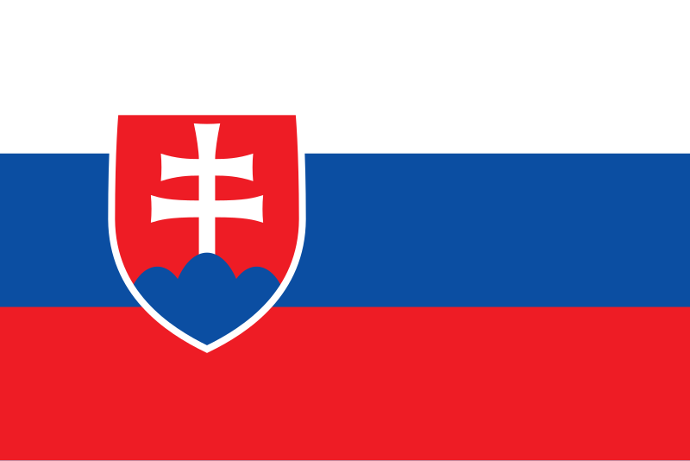

**Committee: United Nations Development Programme (UNDP)**

**Agenda Item:** Strengthening the integration of crisis resilience systems with peacebuilding initiatives and conflict prevention strategies

**Country:** Slovakia

**Delegate:** Furkan Bilginer

Slovakia stands firm when it comes to strengthening the integration systems with member countries which are essential to address crises in order to achieve peace and prevent conflicts. As the global threats such as climate change, resource scarcity and geopolitical tensions rise, we utterly realize the importance of building long term relations and sustainable development goals. Slovakia takes notice of the need for a strong crisis resiliance system, as it is crucial for lasting peace and crisis resilience. As a proud member of United Nations and European Union, Slovakia has always worked for peace and equal conditions between the people both national and international. We are solemnly committed to bolstering international organizations that are focused on finding solutions and any crises that can harm the world peace and integrity of the society.

Slovakia has always been an active partaker of initiatives like European Peace Facility and the Civil Protection Mechanism, which complement crisis resiliance with the ways of capacity building and rapid response mechanisms while also encouraging others to participate actively. As we have seen the importance of resolution of possible conflicts through dialogue and cooperation with the Velvet Divorce in 1993, we see in ourselves that we have a responsibility to showcase our strengths in order to resolve any conflicts that occur in our region as well as in the world. As a firm believer in solidarity, we are sure that if all nations stand together as United Nations, there will be no delays when coming up with efficient solutions. Our SlovakAid program which is established in order to eradicate poverty, foster peace and stability in developing countries, is a true example of our dedication in such matters. With that we assure you that we are going to work as a nation in order to achieve a more resilient and peaceful world.

**Bibliography**

* <https://slovakaid.sk/en/>
* <https://balkaninsight.com/2024/11/20/35-years-of-slovak-democracy-the-struggle-continues-after-all-these-years/>