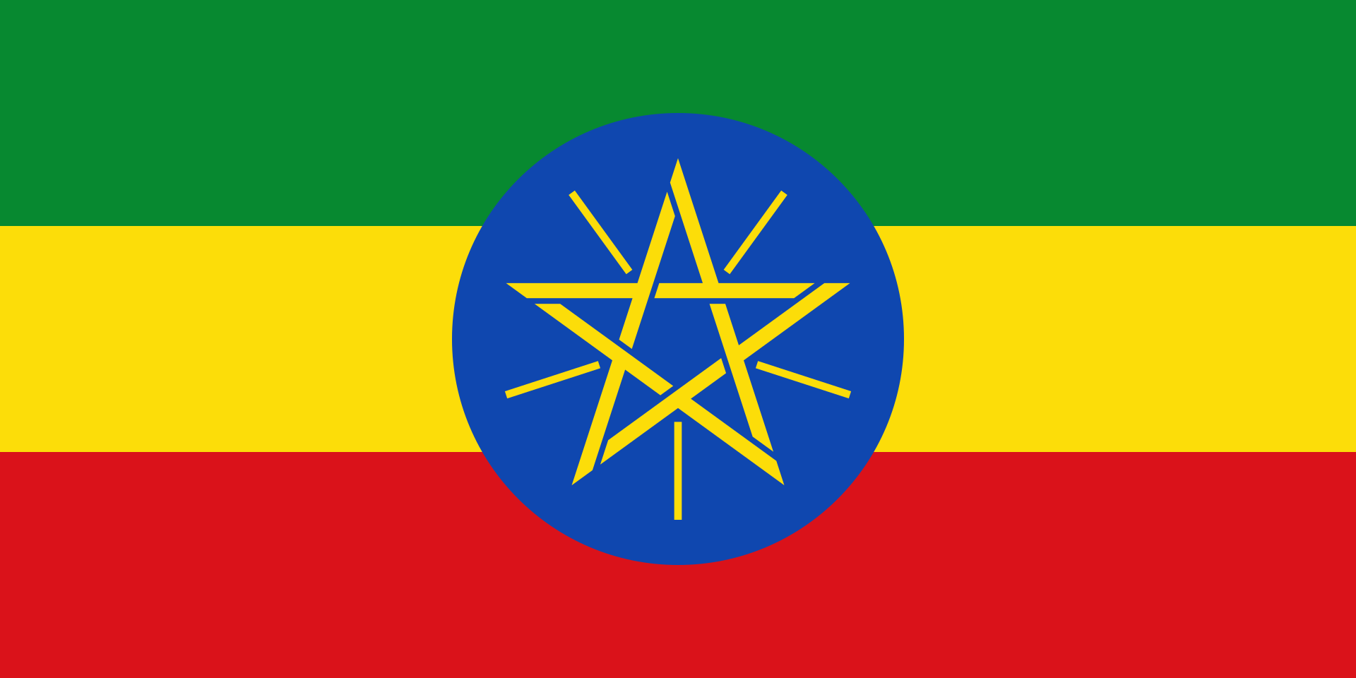***Conference*** : Hacettepe University Training Conference 2024

***Committee*** : United Nations Development Programme

***Country*** : Ethiopia

***Delegation*** : Mehmet Emin Resulzade Anatolian High School

***Delegate*** : Ecrin ARISOY- MERMUN Delegation

***Topic*** : Strengthening the Integration of Crisis Resilience Systems with Peacebuilding Initiatives and Conflict Prevention Strategies

Federal Democratic Republic of Ethiopia is official name Ethiopia. Ethiopia is located in eastern Africa and It has a large surface area.Ethiopian population is 132.9 million people. Ethiopia is the second most crowded country in Africa. Ethiopia became a member of the United

Nations in 1945 and the province became an independent African country.

According to published data, fifty percent of the population in Ethiopia is illiterate. Also, the number of people continuing their education is very low.There are many reasons why people

cannot or will not continue their education.Most people in Ethiopia live below on the poverty line.

Their quality of life is low, so most people cannot afford to provide education for their children.

The other reason is that the materials, school buildings and teachers of the people living in rural

areas are very limited in the country where life is abundant in rural areas.According to a report

by UNICEF, Due to conflicts and threats across Ethiopia; 7.6 million children are unable to

attend school or their schooling is disrupted.But We are looking for and developing solutions for

this.Although we cannot make rapid progress due to some internal conflicts and economic

crises, we are trying to provide educational materials to schools and train new quality teachers

with international support and we are making more comprehensive plans.Addition to these, we

support women's education and entry into the business environment.

For example, on March 28, 2024, more than 750 women's businesses affected by the conflict in Tigray Afar and Amrahada received support through the UNDP mass performance campaign organized in partnership with the Ministry of Women and Social Affairs and the Great Ethiopian Run (GER).

As a result, we believe that an accessible and equal education is the best thing for the country and that we need to continue to carry out projects for this. And we think it is important to be a partner in such projects.

***Bibliography***

*YILDIRIM, Zehra. PATIR, Yağız. Strengthening the Integration of Crisis Resilience*

*Systems with Peacebuilding Initiatives and Conflict Prevention Strategies. Hacettepe University Training Conference 2024 United Nations Development Programme Study Guide. Retrieved from*

[*https://drive.google.com/file/d/1l9ULrz2hLILq0QCQuoCW8Pj7tJqSi1zh/view?usp=sharing*](https://drive.google.com/file/d/1l9ULrz2hLILq0QCQuoCW8Pj7tJqSi1zh/view?usp=sharing)

[*https://www.sondakika.com/egitim/haber-etiyopya-da-7-6-milyon-cocuk-okula-gidemiyor-16455073/*](https://www.sondakika.com/egitim/haber-etiyopya-da-7-6-milyon-cocuk-okula-gidemiyor-16455073/)

*Wikipedia contributors. (2024, December 19). Ethiopia. In Wikipedia, The Free Encyclopedia. Retrieved 19:42, December 19, 2024, from* [*https://en.wikipedia.org/w/index.php?title=Ethiopia&oldid=1263972466*](https://en.wikipedia.org/w/index.php?title=Ethiopia&oldid=1263972466)

[*https://www.undp.org/ethiopia*](https://www.undp.org/ethiopia)

[*https://turkiyeetiyopya.com/ulke-tanitimi-etiyopya*](https://turkiyeetiyopya.com/ulke-tanitimi-etiyopya)