Conference:HUTRAİN’24

Country: Mexico

Comittee: United Nations Development Progremme

Delegate: Defne Teke

Topic: Climate Crisis Adaptation and Relience

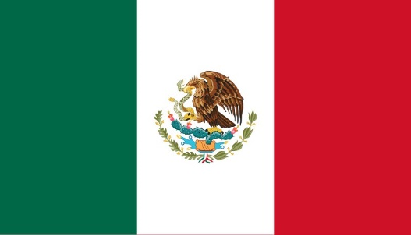

Mexico is a country in the southern portion of North America .And mexico is a coastal country bordering the Pacific Ocean in the west and the Gulf of Mexico in the east.Has population almost 130 million and has the most Spanish speakersin the World. Mexico was founded in 1821 and has been a member of the United Nations since 1945.

Climate change is among the most popular topic in the global problems. As Mexico, we are affected by this problem like other countries in the World. we observe the impact examining the causes climate crisis on our environment.Climate change and global warming have been increasing recently due to human effects such as the increase in greenhouse gases released into the atmosphere, forest fires and deforestation, excessive use of fossil fuels and industrial activities. Unfortunately, if this situation continues, rising sea levels, food and water shortages, extreme temperatures, economic problems and diseases are expected, which are thought to lead to various wars.But there are also things we can do to maket his situation as good as possible. For example: We as countries should make agreements like the Paris Agreement or control greenhouse gas emissions and monitor biodiversity.

We work on this topic also we have instutations for stoping this we want a good world to live in. We believe that this problem, which is very important for the future, will be solved. However, we would like to point out that this can only happen if countries come together. We hope that we will eventually get rid of this problem or manage to reduce it as much as possible.

Bibliography

<https://www.changeclimate.org/?gad_source=1&gclid=EAIaIQobChMIvJaWq-uxigMV2mNBAh0rOwFMEAAYASAAEgIzWPD_BwE>

<https://en.wikipedia.org/w/index.php?title=Mexico&oldid=1263644563>

<https://www.rescue.org/uk/article/10-countries-risk-climate-disaster>

<https://en.m.wikipedia.org/wiki/Mexico_and_the_United_Nations>

TEKE, Defne. YILDIRIM, Zehra.PATIR, Yağız. Operation Overlord. Hacettepe University Training Conference 2024 United Nations Development Progremme Study Guide. Retrieved from https://drive.google.com/file/d/1f6T8ET250gwoIePptmCNDA5R3H--Vx9B/view?usp=sharing