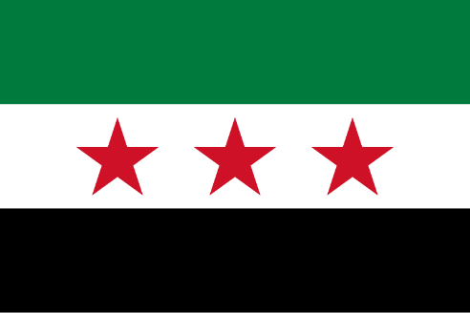**Country: Syrian Arab Republic**

**Committee: FAO**

**Topic: Strategies for advancing sustainable agriculturel practices in the green transition**

Syria, or the Syrian Arab Republic, is located in West Asia on the eastern coast of the Mediterranean Sea and the Levant. To its north lies Turkey, to the east and southeast Iraq, to the south Jordan, and the southwest Israel and Lebanon. It is under a transitional government and has fourteen governorates. The capital and the most important city is Damascus. With an area of 185,180 square kilometers (71,500 square miles), it possesses roughly 25 million people, enough to make it the 57th most populous and 87th largest country in the world.

In the green transition, agriculture has a very important position. While doing this, we should pay attention to product diversification, not harming biodiversity, efficient management of water resources, soil health and precision agriculture. Policies should be directed towards eco-friendly methods and should support smallholder farmers. With these strategies we can increase product efficiency, preserve the ecosystems and reduce the effects of climate change.

            There has been a civil war in Syria for a very long time. Despite the civil war, agriculture has an important place in the economy. The most produced agricultural products in Syria are olives, cotton and wheat. However, with the civil war, the production of these products decreased.Land reforms by the government regularized the relationship between agricultural workers and landowners and distributed land. Yet, the sector has been badly affected due to issues related to water shortages, non-updated methods of irrigation and cuts in subsidies related to seeds, chemical fertilizers, and pesticides.

            The Growing Agriculture and Incomes in Syria (GROW) project is supporting the agriculture sector in Syria and enhancing food security in the non-regime controlled areas of northeast Syria. There are also efforts to promote sustainable farming practices and improve food security, such as conservation agriculture, to enhance livelihoods.

**References:**

https://en.wikipedia.org/wiki/Syria

https://www.usaid.gov/syria/fact-sheets/grow