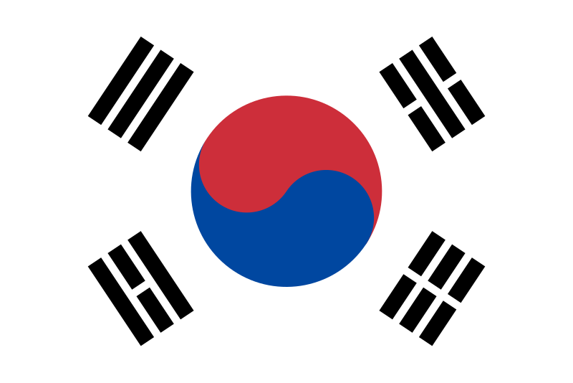

**Country:** South Korea

**Committee:** FAO (The Food and Agriculture

Organization)

**Topic:** Strategies For Advancing Sustainable

Agricultural Practices In The Green Transition

South Korea, also known as the Republic of Korea (ROK), is a country in East Asia. It is located on the southern side of the Korean Peninsula. North Korea borders South Korea to the north. The western border of the country is the Yellow Sea, the eastern border is determined by the Sea of ​​Japan. Seoul is the capital of South Korea. South Korea's population is about 52 million. South Korean Won is the currency. Korean is spoken in South Korea.

In the green transition, sustainable agricultural practices are supported by strategies like agroecology, regenerative farming, and agroforestry in order to reduce their negative impacts on the environment and increase output. A circular economy strategy, crop diversity and effective water management is necessary. Government incentives and farmer education have accelerated the adoption of these methods, which leads to a more resilient and sustainable agriculture system.

South Korea is actively working to make its agricultural sector more sustainable as part of its green transition efforts. South Korea aims to balance food production with environmental protection while addressing challenges like climate change and resource shortage. Incentives and Policies, Encouraging Organic Farming, Improving Water Management, Investing in Research and Innovation, Developing Sustainable Supply Chains and Supporting Farmer Education are the key strategies South Korea use. South Korea is using new technologies like sensors, drones, and artificial intelligence (AI) in agriculture to help farmers monitor crops and manage resources more efficiently.

**Bibliography:**

<https://en.wikipedia.org/wiki/South_Korea>

<https://www.agroberichtenbuitenland.nl/actueel/nieuws/2023/12/12/south-koreas-eco-friendly-agriculture-promotion-act>

<https://news.mongabay.com/2020/05/in-south-korea-centuries-of-farming-point-to-the-future-for-sustainable-agriculture/>