Country: Zambia

Committee: United Nations Development Programme (UNDP)

Agenda Item: Strengthening the Integration of Crisis Resilience Systems with Peacebuilding Initiatives and Conflict Prevention Strategies

Zambia is a landlocked country in south-central Africa. It shares borders with eight countries: Angola, Botswana, Democratic Republic of Congo, Malawi, Mozambique, Namibia, Tanzania and Zimbabwe. It is located on a high plateau and take its name from the Zambezi River, which drains all but a small part of the northern part of the country. Most of the population is concentrated in the country’s most developed area, the capital city, which is Lusaka. Zambia lies within the tropics but its climate is modified by the altitude of the country. In January the rainy season is its peak, and in June the weather is dry. Zambia’s economy is heavily dependent on copper mining. Agriculture is relatively poorly developed. The common country analysis (CCA) highlights the critical challenges of improving access to and quality of services and coping with rapid urbanization. The unemployment rate is close to 52% with a mismatch between job skills and employment opportunities, which is a significant factor. Past growth helped achieve middle-income status up until 2022 but has had a limited impact on poverty.

In 2020, Zambia undertook a Voluntary National Review (VNR) which provided a wealth of information on progress and constraints. The 2021 SDG Index and Dashboards Report gives Zambia a score of 53.4, placing it 141st out of 165 countries. The country is on track to achieve SDG 13 (Figure 2 in Zambia UN Sustainable Development Cooperation Framework 2023-2027). Progress on SDGs 3, 7 and 8 is moderate. The country stalled on eight SDGs (2, 5, 6, 9, 11, 15, 16 and 17). There is no trend data for the four SDGs (4, 10, 12 and 14), and Zambia faces significant challenges in achieving SDG 1.

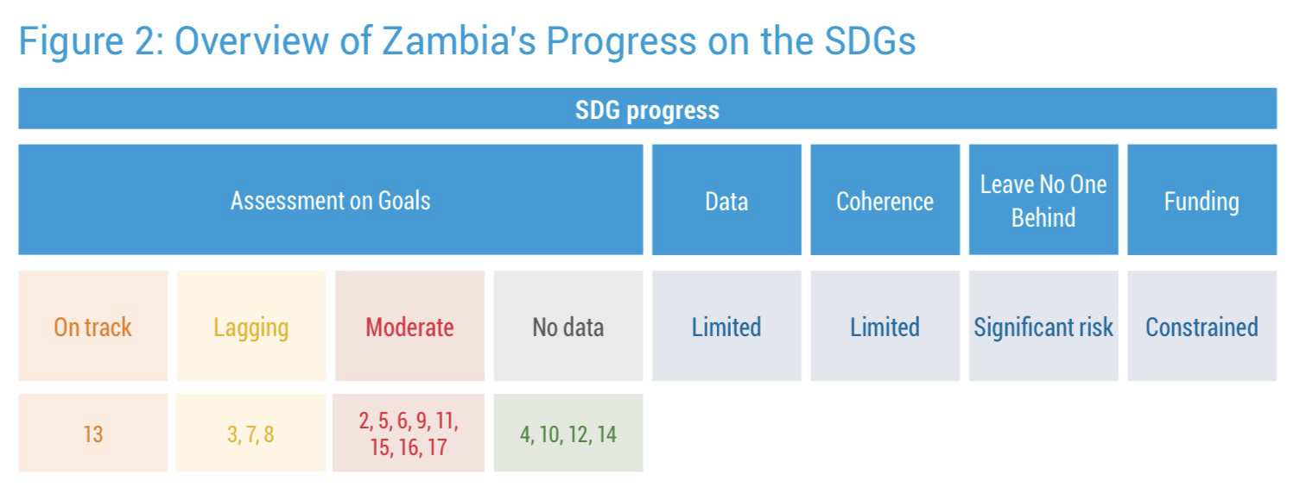

The SDG Indicator Baseline Report shows that required data is available for only a third (34%) of indicators, 51% do not have data and 15% do not have metadata. The statistical capacity assessment identified deficiencies. These are:

* data management mechanisms/systems,
* SDG data sharing mechanisms,
* Inter-institutional and inter-institutional coordination/cooperation,
* sector information management systems.
* data fragmentation and
* Alignment between monitoring and evaluation (M&E) and data availability.

The country has aligned 86% of SDG targets with 7NDP, with 75% of targets fully aligned and 11% partially aligned. However, Zambia's progress towards the Sustainable Development Goals has been hampered by the adverse impacts of climate change, the recent COVID-19 faced several constraints, including the pandemic and funding constraints. Although the social sector budget increased in nominal terms, it decreased as a share of the total budget. The decline in the share of social sector financing was due to the ever-decreasing fiscal space caused by increasing debt service. Zambia has experienced declines in both foreign direct investment (FDI) and official development assistance (ODA) since 2015. ODA inflows have been much lower and more unstable than at their peak before Zambia achieved middle-income status in 2011. FDI inflows have decreased by 50%, reflecting a negative business environment marked by stagnant economic growth and energy shortages. While the impact of remittances on gross domestic product (GDP) is currently marginal, there is potential for growth over time.

"Zambia is collaborating with the International Monetary Fund (IMF) on a funded program to achieve debt restructuring and has invited the IMF to conduct a governance diagnostic." In this collaboration, Zambia is committed to protecting and promoting human rights in line with its commitments under international human rights law. Obligations to comply and fulfill remain critical.

The United Nations Sustainable Development Cooperation Framework (UNSDCF) represents the UN System’s collective offer to assist Zambia in implementing its international legal obligations and to support the country in addressing the key development priorities and challenges to Vision 2030, the 2030 Agenda for Sustainable Development, the African Union’s Agenda 2063 and the 8NDP. The UNSDCF is mutually owned and anchored in national development priorities, the 2030 Agenda and the UN Charter principles. It outlines the UN System’s contributions sought by national stakeholders to reach the SDGs in an integrated manner, with a commitment to Leave No One Behind (LNOB) and to human rights, gender equality and other international principles, norms, standards and obligations. It serves as a core accountability tool between the United Nations Country Team (UNCT) and the government and among UNCT members for collectively owned development results. It shapes the configuration of UN assets required inside and outside the country. The UNSDCF provides the basis for UN entity-specific country programmes.

The UNSDCF presents an opportunity to mobilize multiple stakeholders to assist Zambia in achieving the SDGs. Its success depends on the ability of the UN System to build strategic partnerships in its result areas. A deliberate focus on enhancing partnerships will see the expansion of coherent contributions to SDG achievement across government institutions, civil society, the private sector, development partners and the UN.

The UNSDCF aims to achieve synergies and positive impacts between SDGs while managing potential trade-offs. Programme interventions will target all people in Zambia.

The UNSDCF was developed through an inclusive and participatory process with various stakeholders, including civil society, cooperating partners, academia and private sector representatives. The process was led by the UN Development System under the leadership of the Resident Coordinator (RC), working in close collaboration with the government. Both Resident and Non-Resident Agencies participated in elaborating the new framework. The UN Development Coordination Office provided strategic guidance. The UN Programme Management Team (PMT), with support from the Data Monitoring and Evaluation Group and the Resident Coordinator’s Office, provided overall technical support.

The UNSDCF identifies vulnerable groups based on the core principles of LNOB in accordance with CCA 2021 findings:

• women and girls,

• children, adolescents and young people,

• people with disabilities, including persons with albinism,

• people living with HIV and key populations,

• internally displaced people (IDPs),

• migrants and trafficked people,

• refugees, asylum-seekers, former refugees and stateless people,

• older people,

• LGBTQI+ people,

• prisoners,

• rural populations and people living in remote and hard-to-reach areas.

In identifying these groups, the UN remains conscious of the overlaps in these forms of deprivation.

Recognizing both the threats and the opportunities presented by developments in Zambia’s neighbouring countries, the UNSDCF adopts a proactive approach to engaging the Government of Zambia and other stakeholders on the implications of cross-border issues for the country’s progress. Across each of the programme pillars, the UNSDCF adopts an integrated risk and opportunities management approach that challenges the management structures to actively include monitoring, analysis and action planning to address cross-border challenges and utilize emerging opportunities to enhance outcomes for Zambia.

The linkage of the Cooperation Framework and the AfCFTA is critical to the achievement of outputs and outcomes, particularly the Prosperity Pillar through expanded trade in goods and services beyond the SADC, COMESA and EAC Tripartite Free Trade Area. This linkage will be key in supporting government development plans, particularly on economic transformation and job creation, as industrialization, value addition, beneficiation and the intensification of linkages will generate jobs and wealth within Zambia. UN Zambia is supporting government capacity to participate in the AfCFTA and other regional integration initiatives, such as the Tripartite Free Trade Area. Zambia has deposited the instruments of ratification for both. Subsequently, Zambia has drafted and launched a national strategy for the AfCFTA and has commenced the targeting of specific deliverables, including capacity development among stakeholders such as the government and the private sector.

References:

<https://2021.dashboards.sdgindex.org/profiles/zambia>

<https://www.state.gov/countries-areas/zambia/>

<https://www.britannica.com/place/Zambia>

<https://www.undp.org/sites/g/files/zskgke326/files/2022-11/Zambia%20UN%20Sustainable%20Development%20Cooperation%20Framework%202023-2027.pdf>

<https://en.wikipedia.org/wiki/Zambia>