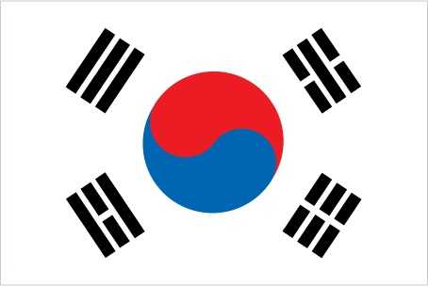
Committee: DISEC
Country: South Korea
South Korea is on Ukraine’s side. We defend the territorial integrity and sovereignty of Ukraine. International law, human rights and the independence of states are very important to us, that's why we defend Ukraine. We provide material and military aid to Ukraine and also implement many of the policies implemented by the West.

This war is critical in our country because our neighbor and enemy, North Korea, and China, which is geographically very close to us, support Russia in this war, the main reason for this is their opposition to the West and their hatred towards America. This puts me at risk and worsens our relationships. But it protects us because of the support of the West and America.
We have been imposing especially technological and financial embargoes on Russia since the beginning of the war. They have frozen many Korean countries and were deprived of most technological devices. This has greatly affected the Russia-South Korea trade. Apart from this, we provide humanitarian aid to Ukraine and extend our help to the victims.
We provide direct military aid in the Russia-Ukraine war, the most important reason for this is our military relations with Russia and the threat of North Korea, our neighbor and enemy, but for the security of our country, we remain a little calmer on this issue and provide more humanitarian aid. The reason for this is that we do not want tension and a possible war with North Korea because we defend world peace so that our enemy, North Korea, does not create a problem in our country and on our borders.

The people of South Korea have been supporting Ukraine since the first day and want to do something. Various non-governmental organizations also act as intermediaries here, the people empathize with the victimized people and the Ukrainians and provide financial aid for them, especially the people who provide humanitarian and material aid support Ukraine and both sides want to do something as soon as possible. They want the war to end, so our people care about world peace and human rights.
Delegate of the South Korea.

