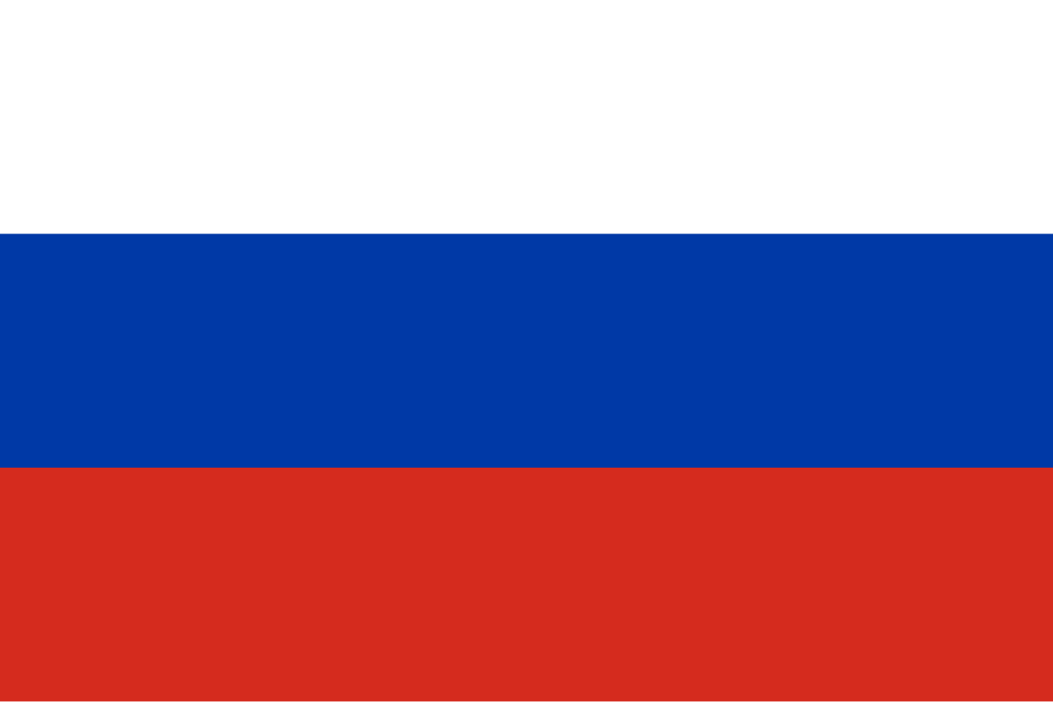
Country:Russian Federation
Committee:UNFCCC
Agenda Item;Increasing the Use of Renewable Energy Sources in Developing Countries

The Russian Federation, the world’s largest country, is located in Eastern Europe and Northern Asia, sharing borders with 14 nations. With a population of 144 million, it remains a global leader in energy exports, mostly using fossil fuels such as oil and gas.Russia's vast natural landscapes offer significant potential for renewable resources, such as wind, solar, and hydropower, especially in remote areas.As Russia, we view the high amounts of usage on non-renewable energy sources as a serious global challenge. When fossil fuels are burned, they release significant amounts of carbon dioxide, which unfortunately causes greenhouse gas emissions ,leading to climate change and global warming. These emissions cause harmful effects, such as rising sea levels, extreme weather events, and biodiversity loss. Renewable energy sources produce no greenhouse gas emissions, unlike fossil fuels. Additionally, renewable energy has numerous benefits, including reducing air pollution and mitigating the impacts of global warming , also they are environment-freely and they produce minimum secondary wastesTherefore, we emphasize the importance of increasing the usage of renewable energy, especially in developing countries.
2ND PARAGRAPH(DRAFT)
The issue of **increasing the usage of renewable energy sources in developing countries** is critical in the fight against climate change. As developing countries industrialize, their energy needs grow significantly, often leading to a higher demand for fossil fuels. This increases carbon emissions, contributing to global warming and environmental degradation. Transitioning to renewable energy is crucial to mitigate these negative effects, and it offers the potential for cleaner, more sustainable growth. Renewable energy sources like solar, wind, hydro, and biomass provide the opportunity to reduce dependence on fossil fuels while promoting energy security and reducing greenhouse gas emissions.The history of this issue is rooted in the global shift toward sustainability, which gained momentum after the 1992 **United Nations Framework Convention on Climate Change (UNFCCC)**, followed by the **Kyoto Protocol** in 1997, and the **Paris Agreement** in 2015. These agreements emphasized the need to reduce global greenhouse gas emissions and transition to cleaner energy sources. The **Paris Agreement**, in particular, urged all countries to limit global temperature rise to well below 2°C above pre-industrial levels, fostering a worldwide commitment to the adoption of renewable energy.For Russia, this agenda holds particular significance due to its vast energy reserves and dependence on fossil fuels. Although Russia is one of the world's largest exporters of natural gas and oil, the country has acknowledged the importance of diversifying its energy sources. Russia's renewable energy policies, however, have been slow to develop. In 2013, Russia launched its **National Renewable Energy Program**, which aimed to increase the share of renewables in the national energy mix, focusing primarily on wind, solar, and hydropower. However, challenges persist, including the country’s vast geography, outdated energy infrastructure, and reliance on fossil fuel exports. Despite this, Russia’s government has recently shown interest in developing renewable energy sources in remote areas such as Siberia and the Far East, where the potential for hydroelectric power and wind energy is abundant.

---

