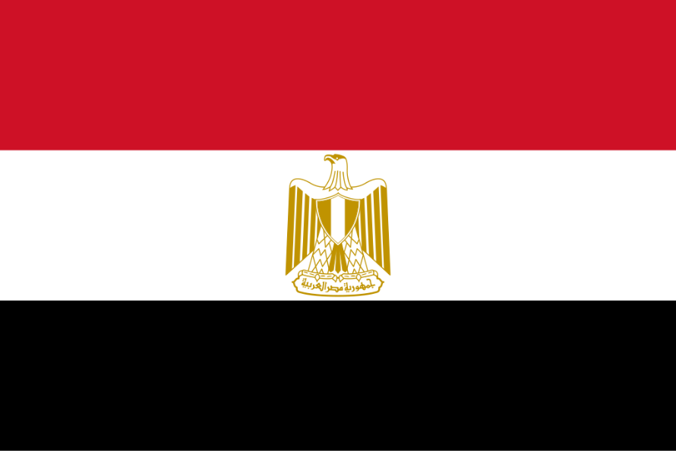
Egypt

Committee: UNITED NATIONS FRAMEWORK CONVENTION ON CLIMATE CHANGE
Topic: Increasing the Usage of Renewable Energy in Developing Countries Country: EGYPT
Egypt is a country that holds a special place in history, not only because of its remarkable ancient civilization but also for its significance in the modern world. Located in the northeastern corner of Africa, Egypt is bordered by the Mediterranean Sea to the north, the Red Sea to the east, and shares borders with Sudan, Libya, and Israel. The country’s history stretches back over 5,000 years, making it one of the oldest and most influential cultures in human history. Egypt is a country that bridges the an- cient and the modern. Its history is one of the most fascinating and influential in the world, and its present is dynamic and full of potential. From the mysteries of the pharaohs to the bustling streets of Cairo, Egypt continues to be a land of wonder, creativity, and importance.
Let’s talk about the main topic, Egypt is already taking some great steps towards renewable energy, but there’s a lot more that can be done to accelerate the transition. With its vast resources, especially in solar and wind, the government has an opportunity to lead the region and even the world in clean energy. Egypt's energy sector has traditionally been dominated by fossil fuels, but the country has a long history of hydropower usage.
The most significant project is the Aswan High Dam, completed in 1970. The dam provides around 10% of Egypt's electricity and has been a key source of renewable energy in the country.
in early 2010 Egypt started seeing challenges in maintaining fossil fuel supplies. Since 2010 Egypt has aimed to increase the contribution of renewable energy mix. Between 2015-2020 Egypt has invested in wind energy.
The Jebel El-Zeit Wind Farm, located along the Red Sea, was expanded, bringing its total capacity to 580MW.
By the end of the decade, Egypt had built additional wind farms and increased its wind power capacity to over 1.8 GW.
As a result of its growing renewable energy capacity, Egypt positioned itself as a leader in the Middle East and North Africa (MENA) region. Now Egypt is aiming ahead for the future projects to make the world a greener place.
As solutions, we need a comprehensive approach that includes transitioning to renewable energy sources like solar and wind and protecting and expanding forests to absorb carbon. If want to live in a greener world, we should do this things!
Thank you.

Yusuf Kerim Durdyyev

