Position Paper

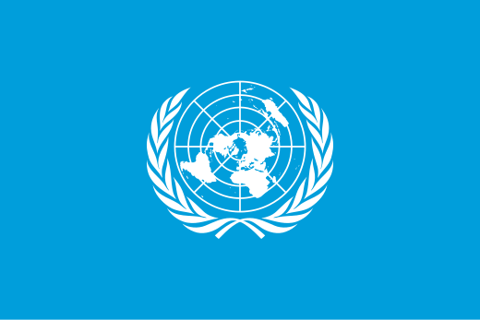

* Country: Republic of Finland
* Committee: Disarmament and International Security Committee / DISEC
* Agenda Item: The Russo-Ukrainian War

Starting in February 2022, the Russian-Ukrainian War is one of the most significant conflicts of the 21st century. Involving not only the 2 main nations: Russia and Ukraine, but also the rest of the world. A lot of countries are constantly aiding and helping the nation they want to win. Whether that is economic and/or military.

Finland fully supports Ukraine, sending economic and military aid, and allowing refugees from Ukraine to rest in our nation. Finland has also joined NATO after the war started, to help NATO in aiding Ukraine in the war.

NATO has also been focusing on ending the war for good, as it originally started as an alliance against the USSR, and now, Russia. Some already think Russia has lost, purely because the invasion was originally set to end in 2 weeks, now that it has almost been 3 years, this just shows how weak Russia has gotten over the years. This might also have to do with foreign aid though.

The Russian annexation of Crimea also makes the invasion for Russia as they have 3 fronts to invade, since Russia’s biggest ally Belarus lets them use their borders freely, allowing an invasion from the north, the east and the south.

Finland believes that we can end this invasion and save Ukraine and its people, if we find actual solutions while aiding Ukraine to make them defend themselves while we work on a solution. Together, we can end this, thank you.