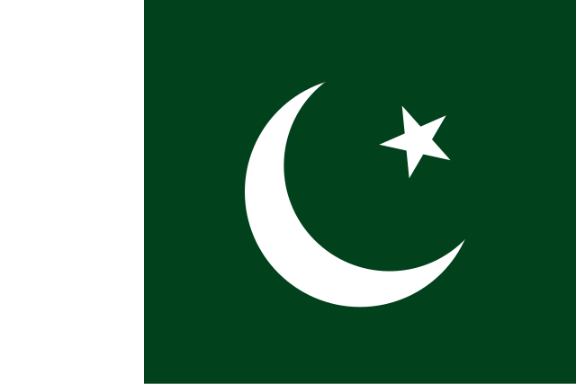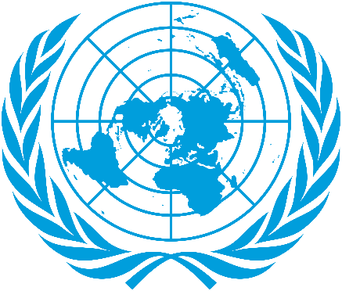

Position Paper

Delegate: Pakistan

Committee: DISEC

Topic: The Russia-Ukraine War and the Use of Weapons

Introduction

The Islamic Republic of Pakistan, situated in South Asia, holds a significant position in international diplomacy due to its strategic location, historical challenges, and commitment to global peace. As a founding member of the United Nations and an active participant in the Non-Aligned Movement, Pakistan remains steadfast in its belief in diplomacy, sovereignty, and the peaceful resolution of conflicts. Pakistan’s foreign policy is grounded in the principles of international law, mutual respect, and non-interference.

Historical Context and Pakistan’s Relevance to the Topic

The Russia-Ukraine war, one of the most pressing geopolitical conflicts of the 21st century, has resulted in massive humanitarian crises, violations of international law, and the use of sophisticated and deadly weapons.

Pakistan itself has experienced the devastating consequences of armed conflicts, from its partition in 1947 to the wars with neighboring India. As a nuclear-armed state, Pakistan fully understands the risks of escalating conflicts and the catastrophic potential of modern weaponry.

Pakistan has consistently voiced its opposition to the use of violence and has advocated for dialogue and negotiations. During the Cold War, Pakistan maintained a delicate balance between the United States and the Soviet Union, positioning itself as a proponent of peace rather than confrontation. Additionally, Pakistan has supported international efforts to curb the proliferation of weapons of mass destruction (WMDs) and played a crucial role in the global fight against terrorism.

Pakistan’s Policy on the Russia-Ukraine War

Pakistan adopts a neutral yet constructive stance regarding the Russia-Ukraine conflict. While Pakistan maintains strong ties with Russia in areas such as energy and defense, it also respects Ukraine’s sovereignty and territorial integrity. Pakistan believes that the continuation of this war will only deepen human suffering, destabilize global economies, and escalate tensions between major powers.

Pakistan stands firm in its belief that:

1. Respect for Sovereignty: All nations must respect the sovereignty and territorial integrity of others, as outlined in the UN Charter.

2. Diplomatic Solutions: War is never the answer. Pakistan urges all parties involved to engage in meaningful dialogue facilitated by neutral mediators.

3. Accountability for War Crimes: Violations of international humanitarian law, including attacks on civilians and the use of illegal weapons, must be investigated, and those responsible held accountable.

Proposed Solutions

Pakistan believes that DISEC, as a UN committee, has a critical role in addressing the use of weapons and the impact of the Russia-Ukraine war. Pakistan proposes the following solutions:

1. Strengthened International Regulations on Weapons:

• Establish stricter international agreements on the use and trade of weapons, including WMDs, autonomous drones, and cyber weapons.

• Reinforce existing treaties like the Nuclear Non-Proliferation Treaty (NPT) and the Chemical Weapons Convention (CWC).

• Develop new frameworks to regulate the use of emerging technologies in warfare, such as artificial intelligence and robotics.

2. Creation of a UN-Supervised Arms Reduction Initiative:

• Encourage both Russia and Ukraine to participate in disarmament talks under UN supervision.

• Gradually reduce the presence of advanced weaponry in the conflict zone to lower the risk of escalation.

3. Humanitarian Aid and Refugee Support:

• Increase international aid to support refugees and civilians affected by the conflict.

• Establish a global fund to assist countries hosting refugees from the Russia-Ukraine war.

4. Promotion of Dialogue Through Neutral Mediators:

• Initiate a special UN-led peace dialogue with the participation of neutral countries such as Turkey or Switzerland.

• Offer Pakistan’s services as a mediator to facilitate negotiations between Russia and Ukraine.

5. Accountability Mechanisms:

• Set up an independent international commission to investigate the use of illegal weapons in the conflict.

• Ensure that war crimes and violations of international humanitarian law are tried in international courts.

Conclusion

As a country with a history of navigating complex geopolitical challenges, Pakistan reaffirms its commitment to global peace, the protection of human rights, and adherence to international law. Pakistan believes that only through dialogue, cooperation, and accountability can the Russia-Ukraine war come to an end. DISEC must take decisive action to prevent further human suffering and ensure that the use of dangerous weapons is strictly controlled. Pakistan stands ready to support all efforts aimed at achieving lasting peace.