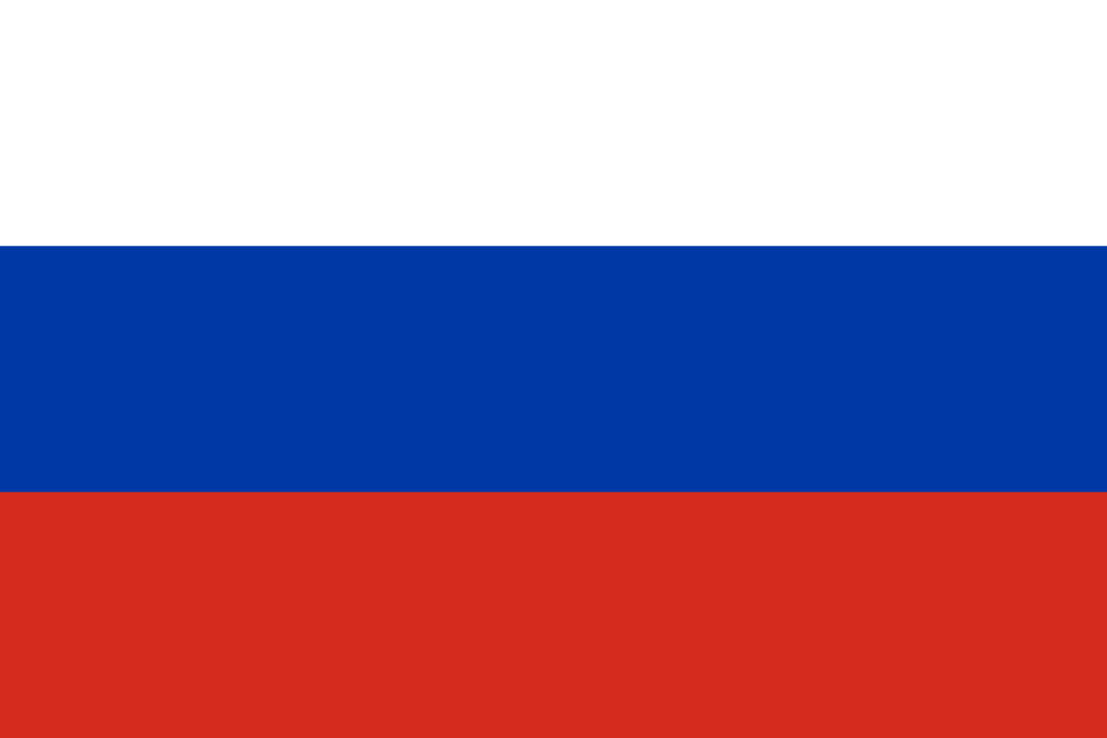

**Russia  
World Health Organization (WHO)**

**The Impact of Climate Change on Global Health and Mitigation Strategies**

The Russian Federation acknowledges that climate change is not just an environmental issue but a health emergency affecting millions of lives globally. Rising temperatures, extreme weather events, and environmental degradation intensify the spread of vector-borne diseases, malnutrition, and respiratory illnesses. Russia firmly believes that climate change demands immediate international cooperation, with a particular focus on strengthening healthcare systems to protect vulnerable populations.

The increase of anthropogenic greenhouse gas emissions in the atmosphere is causing climate change. As a global leader in energy and natural resources, Russia knows its responsibility in mitigating climate change. The Federation ratified the Paris Agreement in 2019 and has committed to reducing greenhouse gas emissions to 70% of 1990 levels by 2030. Between 2010 and 2020, Russia reduced its carbon emissions by 30%, while increasing investments in renewable energy and sustainable development projects. In Siberia, reforestation efforts have restored over 1.3 million hectares of land, mitigating the effects of permafrost thaw. Moreover, Russia has implemented national strategies to address public health impacts, such as launching heatwave response programs and combating pollution-related respiratory diseases.

The Russian Federation proposes a unified global response with clear, actionable steps to address the intersection of climate change and public health:

1. **Strengthening Health Infrastructure**: By 2030, Russia aims to modernize 80% of its healthcare facilities to cope with climate-related illnesses, particularly in rural and vulnerable regions.
2. **Establishing a Global Climate-Health Research Network**: Russia is creating a WHO-led collaborative platform for sharing data and best practices on climate-related health challenges.
3. **Technology and Financial Support for Developing Nations**: Russia commits to providing technical expertise and funding for clean energy and climate adaptation programs, focusing on Africa and Southeast Asia by 2025.
4. **Investing in Clean Energy Solutions**: By 2035, Russia plans to increase its renewable energy production to 25% of the total energy mix, significantly reducing air pollution-related diseases.

The Russian Federation calls on all nations to work together to protect public health and combat climate change. Together, we can achieve sustainable progress, protecting both present and future generations.

**REFERENCES**

1. United Nations Framework Convention on Climate Change (UNFCCC) - Paris Agreement ratification details: <https://unfccc.int/process/the-paris-agreement/status-of-ratification>
2. Russian Federation’s National Climate Strategy and Emission Reduction Targets, 2019: <https://unfccc.int/sites/default/files/resource/Strategy%20of%20Socio-Economic%20Development%20of%20the%20Russian%20Federation%20with%20Low%20GHG%20Emissions%20EN.pdf>
3. International Energy Agency (IEA) - Renewable energy investments and progress in Russia: <https://www.iea.org/reports/russia-energy-policy-review-2020>
4. World Bank - Data on reforestation efforts in Siberia and mitigation strategies: <https://data.worldbank.org/indicator/AG.LND.FRST.ZS?locations=RU>
5. World Health Organization (WHO) - Climate change and public health impact reports: <https://www.who.int/health-topics/climate-change>
6. Intergovernmental Panel on Climate Change (IPCC) - Data on anthropogenic greenhouse gas emissions: <https://www.ipcc.ch/report/ar6/wg3/>
7. Russian Ministry of Health - National strategies for combating pollution-related illnesses and heatwave programs: <http://www.rosminzdrav.ru/>