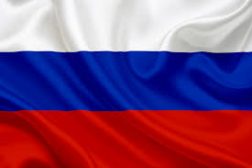Country: Russia

Comitee: United Nations Enviroment Programme (UNEP)

Topic: Global Solutions for Reducing Marine Plastic Pollution

Honorbale chair and fellow delegates, As the delegate of Russia, we are proud to be part of this meeting. We are here to discuss Global Solutions For Reducing Marine Plastic Pollution.

Marine Plastic Pollution is too much in the Russia .Marine Plastic Pollution is major problem with Marine Plastic Pollution in Russia. The Sea of Azov has the most Marine Plastic Pollution in Russia. The most Marine Plastic Polluted city in Russia is Rostov-on-Don. It’s near the Sea of Azov .Did you know that Marine Plastic pollution can kill a person? When the oceans are dirty, it means air will be dirty too.

When the air is dirty people will breath in dirty air and they can get breathing problems or they can die.

People get ill from dirty water, but what about animals that lives in the oceans and seas? They can drown with plastics or they can eat plastics and die .Let’s speak about my first example, some fishes, whales , sharks and jelly fishes think that plastic bags is a fish and they want to go closer to it, and when they go closer they can drown with plastic bags .Now let’s speak about my second example,when the animals that live in the oceans think that plastics are food and they eat it , and then they die.

Russia produce 11.1 milion metric tons in a year, and half of this plastics go to oceans, rivers and seas.

Some strong countries can help to the Russia. For example : The USA, China and Japan .You must ask how they can help? They can send helicopters and ships to The Russia .Some boats are helping to sold this problem.

Thanks for listening

References: ScienceDirect.com and Wikipedia