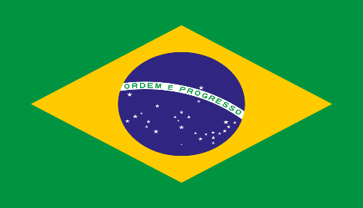Country: Brazil

Comitee: United Nations Framework Convention on Climate Change

(UNFCCC)

Topic: İncreasing Renewable Sources in Developing Countries

Brazil, with its official name Federative Republic of Brazil, It is the largest and most populous country in South America. Covering 47.7% of Latin America. Brazil shares borders with all South American countries except Ecuador and Chile. Its capital is Brasília and its most populous city is São Paulo. Brazil is a federation of 26 states and one Federal District, and is the only South American country where Portuguese is the official language. The largest cities in Brazil, which has thirteen cities with populations over 1 million, are São Paulo (12.1 million) and Rio de Janeiro (6.6 million).

The UNFCCC is an international agreement that aimed at reducing and keeping global warming under control. It was opened for signature in 1992 at the United Nations Confrence on Environment and Development held in Rio de Janeiro, Brazil, where a lot of global environmental issues, including climate change and global warming were addressed at that time.

In our world renewable energy sources are very important for the present time and for the future. The reason is that our world is heating because of the Greenhouse gases. Greenhouse gases trap heat in our atmosphere, causing global warming. The average global tempature has increased by 1°C. Warming 1.5°C above the normal atmosphere heat can cause dangerous risks for the nature like sea level rising, extreme weather conditions etc. For the people global warming can cause such as food scarcity because of dirty air conditions that effects to the soil to dry out faster than usual and increasing the risk of illnesses and death from extreme heat and poor air quality. İn developing countries such as the Philippines goverment sees the growth of the renewable energy sector essential for national energy security. The philippines fosil fuel sector is unsustainable, being dependent on the import of nonrenewable fuel, including petroleum, but has significant ptential in the renewable energy sector. Based on the report of an Australian consulting firm, İnternational Energy Consultants, the Philippines has the highest electricity rate in Asia. The Philippines could be considered as a world leader in renewable energy, with its 30 percent of its power generation being powered by the renewable energy sector. In the world there is an International Renewable Energy Agency (IRENA). The IRENA is an intergovernmental organization mandated to facilitate cooperation, advance knowladge and promote the adoption and sustainable use of renewable energy and its the first international organization that focuses on renewable energy.

The possible solutions for increasing renewable energy sources for developing countries are increasing financial support which means that the developed countries can help to developing countries for the high initial costs of renewable energy projects with creating international funds, developing countries can have renewable technologies easier and the second possible solution is that we can raise awarness in people which can be education campaigns about the benefits of renewable energy can increase public support, leading towards to a greater demand for green energy community involvement in projects