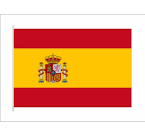
Country: Spain
Comitee: UNFCCC
Topic: The usage of renewable energy ın developing countrıes

Honorable guests and fellow dellegates as the delegate of spain we are proud to be part of this meeting we are here to discuss increasing the usage os renewable energy in developing countries

Renewable energy inculudes wind,Hydro and solar energy, biomass and geothermal energy sources.
Spain has long been a leader in renewable energy and recently became the first country in the world to rely on wind as its primary source of energy all year round. The country aims to meet forty percent of its electricity consumption with wind power by two thousand twenty.at the same time,Spain is developing other renewable energy sources especially solar photovoltaic.Renewable energy based power in Spain reached forty seven percent of total power consumption in two thousand twenty-one.

We can do things like solar panels and wind turbines on the roofs of buildings to increase renewable energy. Or, if we do something simpler, we can turn off the lights we don’t use and use energyefficient electronic devices and lighting systems. In addition, we can increase renewable energy by taking advantage of ocean energy, waves and tides.

As a result, we must use the basic resources that natüre provides us, such as water,air,sun,wind and so on , for our future.
Thank you for listening to me.

