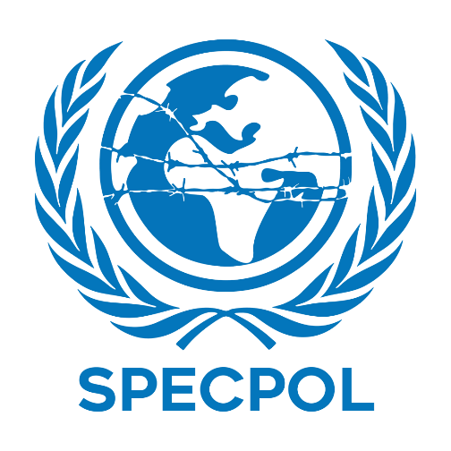grafik, daire, kırmızı, ekran görüntüsü içeren bir resim

Açıklama otomatik olarak oluşturuldu

**Comittee : Special Political and Decolonization Comittee**

**Country : State of Japan**

**Agenda : Establishing a Global Framework for the Protection of Stateless People**

**Delegate : Metehan Çoban**

**daire, renklilik içeren bir resim

Açıklama otomatik olarak oluşturuldu**

The Syrian Civil War has entered it's second decade , this led to severe crisis and caused

significant problems to global security. The delegation of Japan recognises the urgent

need for comprehensive political resolution to conflict and point to the socio-economic

impacts of the crisis on boths Syria and neighbour countries.

State of Japan, as a committed member of the international community recognises the

Syrian Civil War as one of the most pressing and complex crises. The conflict has

caused suffering to millions and thousands of death. So millions from Syria has

immigrated. State of Japan believes that a peaceful resolution must be achieved

through political means and dialogues. State of Japan condemns the violence and

suffering upon the civilians in Syria. As a nation dedicated it's years to bring peace

among humans this conflict had a huge impact on State of Japan's agenda. State of

Japan supports Syrian-led political process under the United Nations Security Council

Resolution 2254. State of Japan emphasises the importance of the stabilisation of

regions affected by the consequences of conflict. Japan believes that any resolution

must respect Syria's territory and ensuring that the voices of stakeholders, including

opposite groups, are heard.

Humanitarian assistance is a cornerstone to Japan in Syrian Civil War.

State of Japan has been providing assistance to Syria and it's neighbor countries to host

refugees. Since the conflict began State of Japan has contributed over $2.9 billion in

humanitarian aid, food delivery, clean water , medical supplies, rebuilding infrastructure

and most important is education to the women and children. State of Japan has worked

with organisations such as United Nations High Commissioner (UNHCR) , the World

**daire, renklilik içeren bir resim

Açıklama otomatik olarak oluşturuldu**Food Programme (WFP) , and Unicef to ensure effective aid distribution.

**Prompting a political resolution**

• State of Japan calls for reinvigoration of the Geneva peace process to ensure

sustainable resolution to Syrian Civil War. This includes gathering all relevant parties

including Syrian government, opposition groups, regional activists and international

organisations.

• Advocates for establishment of neutral zones under UN supervision.

**Expanding Humanitarian Assistance**

• State of Japan proposes the establishment of Un coordinated fund specifically aimed

for supporting Syrian refugees and host countries, ensuring efficient allocation

resources to address immediate needs such as food, water, health care and shelter

State of Japan remains determined in it's commitment to peaceful resolution of the

Syrian Civil War and it's aftermath. The delegation of State of Japan invites all member

States to work collectively and support the principles of the United Nations in

tackling this issue.