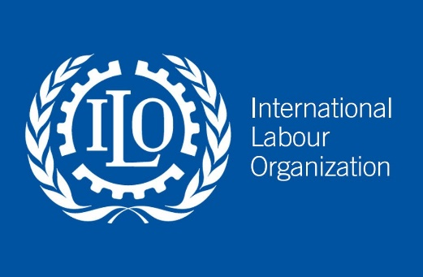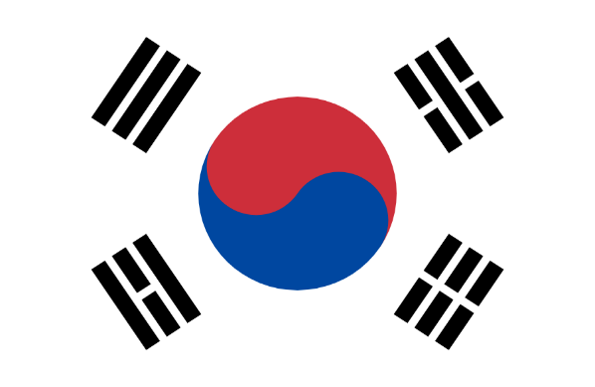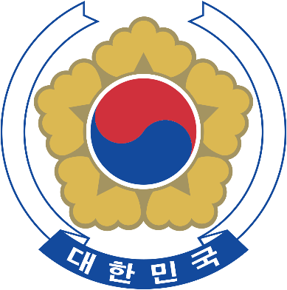

**Committee : International Labour Organization**

**Country : Republic of Korea**

**Agenda: Achieving the Decent Work Agenda Through Reinforcement of Collective Agreements**

**Delegate : Deniz Akıncı (Representative of Employers)**

Since The Korean War, the Republic of Korea has greatly succeeded in becoming one of the

greatest economies in East Asia. However, this success wasn't a coincidence, the Republic of

Korea, as one of the key economies in the global labor market attaches great importance to

keeping the balance between efficient work which proves sustainable economic growth, and

a fair labor environment for employees, and today the Republic of Korea still tries its best to

keep this balance. Today we face problems like long working hours, low wages, uninsured

migrant workers, forced labor, and child labor. The government's insusceptibility and lack of

inspections in labor areas causes these problems, while an employer's first duty is to

guarantee workers' rights and comfort. A 2020 ILO report states that 1 in 5 workers in

developing countries face informal employment without a safe working area. If we were to

give more examples, The Global Slavery Index (2021 Report) reports that 40.3 million people

are estimated to be in modern slavery (71% being women and girls). The Global Wage Report

on 2020-2021 states that income inequality keeps rising, while the top 10% of earners earn

way more than the bottom 50%. If we are to summarize this, The World is still facing huge

problems in labor standards, to find solutions for these issues, governments, employers, and

employees should collaborate in hopes of creating a balanced labor environment.

About MOEL (the Ministry of Employment and Labor) : In 1989, The Occupational Safety

Bureau was established. Following years, The Labor Relations Policy Bureau and the Labor

Management Guidance Office were merged to form the Labor Relations Policy Office. In

2010, the Ministry of Employment and Labor had 3 offices, 13 Bureaus and 40 Divisions.

Finally in 2018, with the establishment of the Employment Support Policy Bureau and the

Labor Inspection Policy Bureau, the Ministry consists of 3 Offices, 13 Bureaus and

45 Divisions. The Labor Standards Act in Korea describes the Government of South Korea’s

policies on labor standards which can include: Working conditions, such as wages,

working hours, and holidays, and guaranteeing and improving workers' basic

livelihoods. The Labor Standards Act is for all businesses or working areas with at least five

workers, but this number could decrease to 4 or fewer depending on the financial conditions

and capabilities. MOEL is trying its best to increase the number of labor inspectors to ensure fair

working conditions in workplaces, also a labor inspection innovation plan is being planned

by the Ministry to strengthen labor inspection’s function to prevent problems. In 2017 the

number of labor inspectors was 1450, with the Ministry’s great efforts the number has

increased by approximately 50% in 2020 becoming 2290.

About KEF (Korea Enterprises Federation): It was founded in 1970 with the name of “Korea

Employers Association”. In 1971 They released the first “Wage Guidelines for Business”

improving the dialogue between employers and employees. It was renamed as “Korea

Employers Federation” in 1981. They have begun participating in Korea’s Minimum Wage

Commission as an employer representative in 1987. They have become a regular member of the ILO in 1991.

They signed the first wage agreement with trade unions in 1993. In 2019 It was renamed as

“Korea Enterprises Federation”. KEF has signed many agreements to increase the quality

of working conditions of employees while creating an efficient working environment that

provides sustainable economic growth. In 2019 Tripartite Agreement of the Economic, Social

and Labor Council on the Improvement of Flexible working-hours Arrangements was signed.

They established the Health and Safety Committee of Enterprises in 2003 ehancing

employee lives. KEF also cooperates with the Korean Government to establish better labor

standards for employees and prevent problems with labor.

Decent jobs are a great way for individuals to improve their productivity and themselves.

Individuals having decent jobs and the state providing people with decent work help

enhance the economy’s growth potential. That’s why creating decent work is the solution to

low growth, social polarization, low fertility, and other problems facing the Korean

economy. The Government intends to establish the circle of employment, distribution, and

growth by increasing income. In 2017 the Presidential Committee on Job Creation

announced the five-year Job Policy Roadmap to establish the fair circle of

employment and distribution.

**First**, the government aims to build a job-oriented governance system. The Government

will ensure the workers that they won't be harmed by the cracks of the employment safety

net. Safeguards will be strengthened against unemployment and industrial accidents. An

education and training system will be set up to prepare people for the Fourth Industrial

Revolution.

**Second,** The government will increase the number of public sector workers to provide

quality services that will fulfill people’s needs and improve the economy's medium- and long

term growth potential. This could be done by expanding job options for young people,

creating more jobs… The working hours will be reduced with balance.

**Third,** the government will promote the creation of innovative startups, and enhance

industrial competitiveness. The government will boost the social economy and support job

creation in new promising industries, such as environment-friendly smart cars, autonomous

vehicles and smart cities, by promoting convergence and reforming regulations.

**Fourth,** The government will prevent non-discrimination in workplaces to improve the

quality of jobs as well as prevent excessive use of non-regular employment. The

government will also reduce working hours as told before, and raise the minimum wage.

**Fifth and Finally,** The government will promote jobs for youth and women providing support

to each industry and employment stage. The life quality of the youth and women will be

improved achieving a balance between work and life.

We suggest local solutions instead of universal solutions, the reason for this is that every

the country has its own culture, people, and economic and political structure.

**Enhancing the Dialogue Between Parties and Establishing Social Partnership**

To create decent work, an efficient dialogue between employees, employers, and

the government must be set up where they can collaborate and communicate

actively. This can ensure significant impact on Collective agreements, and all sides

would have fair outcomes.

**Setting Up a Strict Labor Inspection**

There are still employers who employ illegal workers, or uninsured migrant workers.

To profit more, with the government’s inspection teams, this could be prevented.

This could also prevent forced labor, child labor, low wages, etc.

Thank you.

**BIBLIOGRAPHY**

[**https://www.moel.go.kr/english/**](https://www.moel.go.kr/english/)

[**https://www.moel.go.kr/english/policy/employment.do**](https://www.moel.go.kr/english/policy/employment.do)

[**https://www.moel.go.kr/english/policy/laborStandards.do**](https://www.moel.go.kr/english/policy/laborStandards.do)

[**https://www.kefplaza.com/web/english/index.do**](https://www.kefplaza.com/web/english/index.do)

[**https://www.kefplaza.com/web/pages/gc26696h.do**](https://www.kefplaza.com/web/pages/gc26696h.do)

[**https://ilostat.ilo.org/data/asia-and-the-pacific/**](https://ilostat.ilo.org/data/asia-and-the-pacific/)