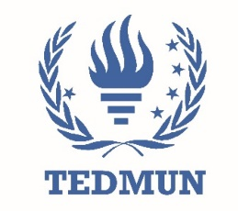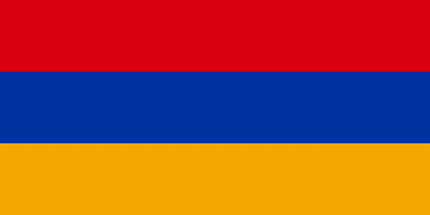**COUNTRY: Republic of Armenia**

**COMMITEE: LEGAL (GA:6)**

**TOPİC: Legal framework concerning the protection of prisoners of war during war times and its safe conduct**

As a country, which has been established in 1917 Armenia suffered numerous times due to its geographical location and the country’s lack of potent, subsequently due to the collapse of the Soviet Union, Armenia became an independent country. Armenia still depends upon reinforcing the country. Furthermore as a consequence of the past complications amongst the neighbours of Armenia, due to the high sensitivity and controversy of these topics (for instance: the forced immigration of Armenians during the Independence War), the meetings upon this topic have been avoided and delayed.

The susceptibility of Armenia’s bonds with other countries has increased to some extent due to the past wars and complications which rose from the unprotected, tortured and innocent Armenian civilians during World War Two (Despite the fact that we did not participate the Armenian population still faced a huge number of fatalities because of the war.) and the Soviet invasion of Armenia.

Introducing the report, Vahe Gevorgyan, Deputy Foreign Minister of Foreign Affairs of the Republic of Armenia and head of delegation, said that two weeks ago, tragic events had occurred in the region. The Azerbaijani military aggression against the people of Nagorno Karabakh on 19 September, 2023 led to serious and massive violations of human rights, including the right to life, and international humanitarian law.1 Instead of wars and conflicts; arranging worldwide conventions and meetings would decrease the number of complications rapidly, incidentally as seen in the past The Republic of Armenia is a country, which values the human rights and is aware of the vulnerability of these circumstances.

The Azerbaijani military aggression against the people of Nagorno Karabakh on 19 September 2023 led to serious and massive violations of human rights, including the right to life, and international humanitarian law.  The use of force had disastrous effect on the enjoyment of all human rights enshrined by the core international human rights instruments and this Covenant. 2 This information clarifies us that our rights were neglected once again, as stated in the Fourth Genova Convention civilians shall not be included in the war or any armed attacks.

As of 4 October, more than 100,000 Armenians had been forcibly displaced.  Strong international monitoring and protection were needed to fully restore the rights of the Armenian population and bring those responsible to justice.3

Tens of thousands of people have fled their homes, leaving their belongings and livelihoods, and require support. The humanitarian situation for those who remain is precious: people need healthcare and other essential services. Telecommunications are disrupted, resulting in difficulties for families to contact one another.4

 Signing treaties and creating international laws stating our country’s rights, which includes our right to get our war reparations paid due to the neglection of our civils’ and soldiers’ rights during WW2 and the Soviet Invasion. Considering the past complications and conflicts we are obligated to create new regulations by seeing the old Geneva conventions as a precursor and reminding countries the old treaties upon this topic to make the fellow countries obey them as well.

We believe that our previous war reparations should be fulfilled – due to the multiple times we had to suffer from other country’s disobedience towards the conventions and treaties.

In conclusion, in order to reinforce the countries and their bonds we are obligated to decrease our reluctancy towards having meetings with middle eastern countries such as Turkey, Azerbaijan, consequently after discussing and agreeing on a joint resolution while simultaneously strengthening our lodges in the USA there will be a decrease in the probability of any possible wars and complications.

Bibliography:

1. <https://www.ungeneva.org/en/news-media/meeting-summary/2023/10/examen-de-larmenie-au-comite-des-droits-economiques-sociaux-et>
2. https://www.ungeneva.org/en/news-media/meeting-summary/2023/10/examen-de-larmenie-au-comite-des-droits-economiques-sociaux-et
3. https://www.ungeneva.org/en/news-media/meeting-summary/2023/10/examen-de-larmenie-au-comite-des-droits-economiques-sociaux-et
4. https://www.icrc.org/en/document/armenia-azerbaijan-evacuating-wounded-delivering-humanitarian-relief

DELEGATE: Republic of Armenia

Gökçe PAMUKCU