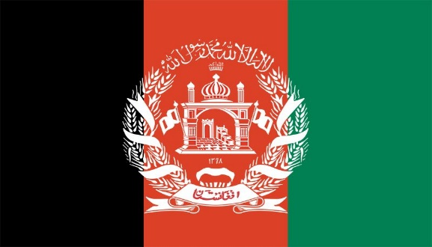

**Committee:** UN Women

**Topic:** Empowerment of Women

Afghanistan, officially known as the Islamic Emirate of, is a landlocked country in the South of Central Asia. Pakistan in the East and South; Iran in the West; Turkmenistan, Uzbekistan and Tajikistan in the North; It borders China in the Northeast.

Women are not valued in Afghanistan. In Afghanistan, women must cook, clean the house and take cair of their families. The marriage age in Afghanistan is 16. In Afghanistan, women were required to cover themselves. In addition, 14,2 million of Afghanistan’s population are women and 15 million are men.

Even though the Afghan government sometimes gives rights to women, the people do not comply and continue to mistreat women. The state establishes ministries for women and gives them rights such as education, health and participation in politics. The Taliban regime, which declared its rule in Afghanistan on August 15, 2021, tried to get support from world countries by saying that it had given up its harsh policies in the 90s and by giving "moderate" messages, especially regarding women's rights. But he forgot his promise within a month and turned the country into a prison for women and girls within two years.

According to the rules of the Taliban, women living in Afghanistan; going to school, working, doing sports, singing, going to the park or on a picnic, going to the hairdresser, going to places of worship, taking a taxi without a male relative, going to the doctor, traveling more than 72 kilometers alone, driving; It is forbidden to breathe, so to speak.

Things that can be done to be make women and men equal in Afghanistan are not to force women to do anything, to give them freedom and rights, to remove laws restricting women, to raise awareness of individuals and to offer women their rights as they are.